|  |
| --- |
| AWS Logo - LogoDix |
| AWS Cloud FoundationsModules 7-10Derek Liu |
| Periods 0,3,4  Mr. Mason & Mr. Hansen  CCNP Lab 9 |

**AWS Cloud Foundations Academy***Derek Liu*

Purpose

This isn’t necessarily a lab but rather working through the AWS Cloud Foundations Academy curriculum with the goal of obtaining an AWS Cloud Foundations certification. This lab will contain modules 7 through 10.

Background Information

The Amazon Web Services Cloud Foundations Certifications is an entry-level certification. It is used to represent basic understanding of the AWS cloud. In this lab, we go through a curriculum meant to prepare students to take the AWS Cloud Foundations Certification test. In order to obtain the certification, students must pass a multiple-choice exam that covers information on AWS Cloud infrastructure, security, billing, and core AWS services. The Cloud Foundations Certificate is a prerequisite for many other AWS certifications.

Module 7: Storage

Amazon Elastic Block Store or Amazon EBS provides persistent block storage volumes for use with Amazon EC2 instances. Persistent storage is a storage system that retains data after device is shut off. EBS is designed for high availability and durability.

Different types of storage. If you wanted to change something in a file, block storage allows you to change one block, or piece of the file, that contains the character. Object storages on the other hand must have the entire file reuploaded if something needs to be changes. Block storage is more cost effective.

Amazon EBS enables you to create individual storage volumes and attach them to an Amazon EC2 instance. EBS backups are called snapshots. The first snapshot is called the Baseline snapshot and all other snapshots capture only what is different from the previous snapshot. Snapshots can be copied or shared to difference AWS regions.

Storage cost can be reduced by choosing the right storage type. Only SSDs can be used as boot volumes for EC2 instances. EBS volumes can be encryption. Storage is charged in gigabytes per month until storage is released. Inbound data transfer is free but outbound data transfer across regions costs money.

**Lab 4: Working with EBS**

Step 1: Click “start lab”

Step 2: Click “AWS”

Step 3: Go to Services to EC2

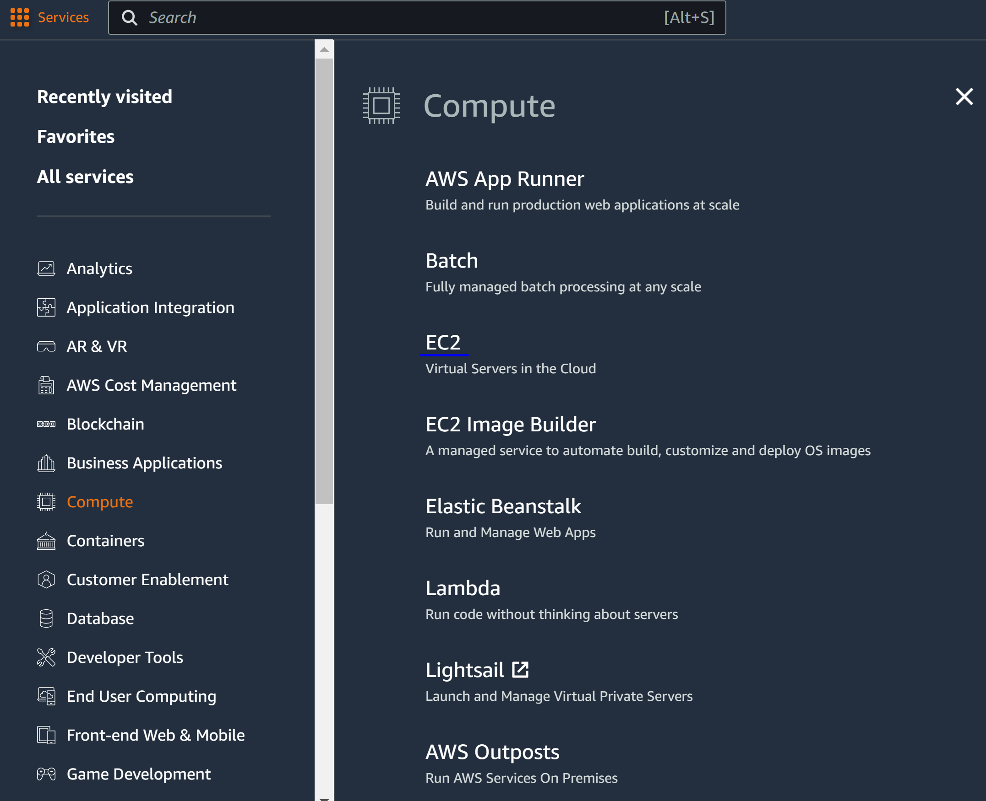

Step 4: got to Volumes and Create Volume

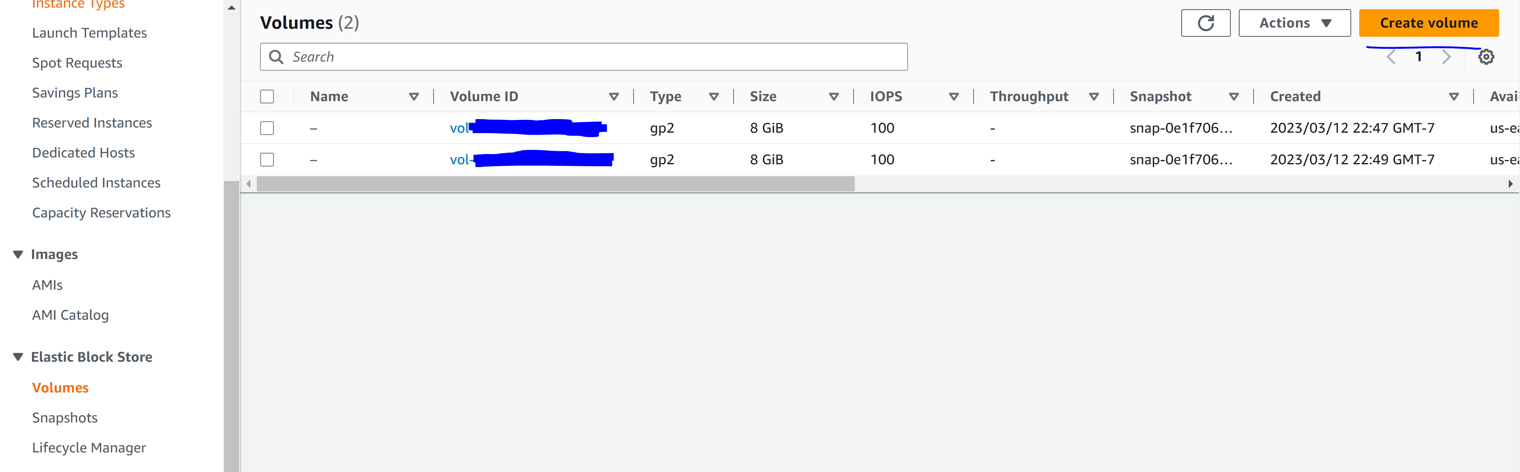

Step 5: Configure the following

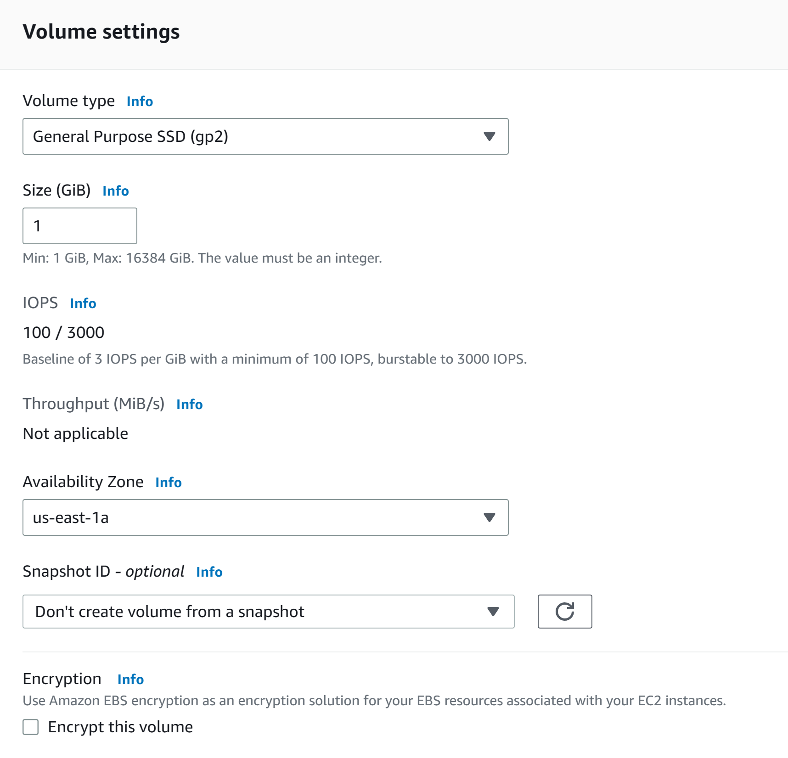

Step 6: Configure the following

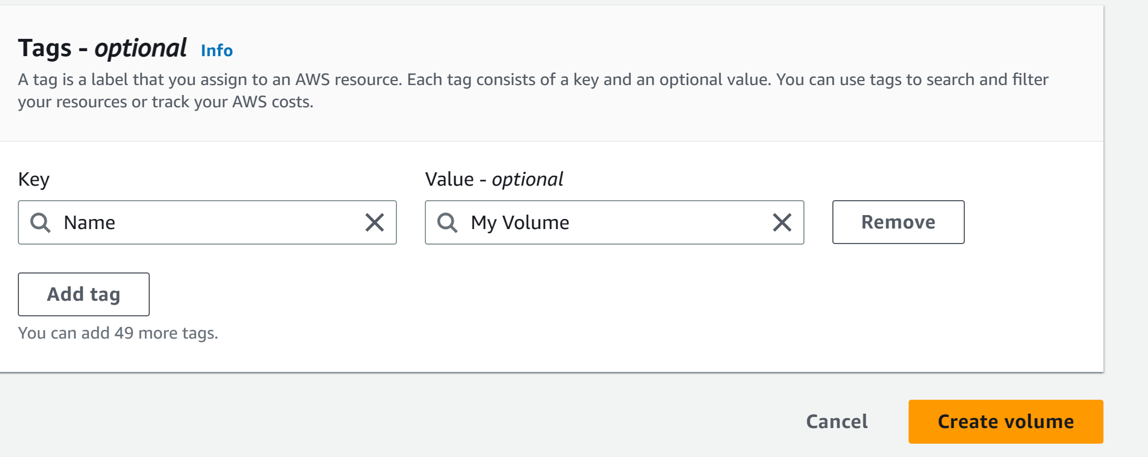

Step 7: Go to actions and Attach Volume

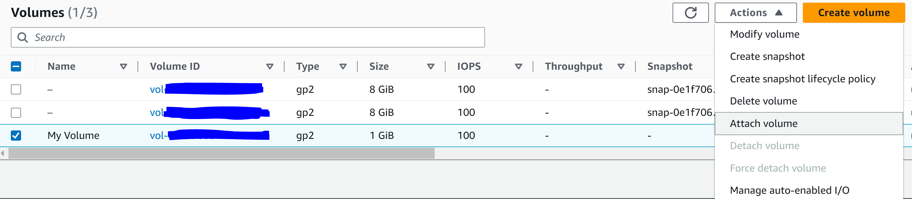

Step 8: select the “lab” instance and click attach volume

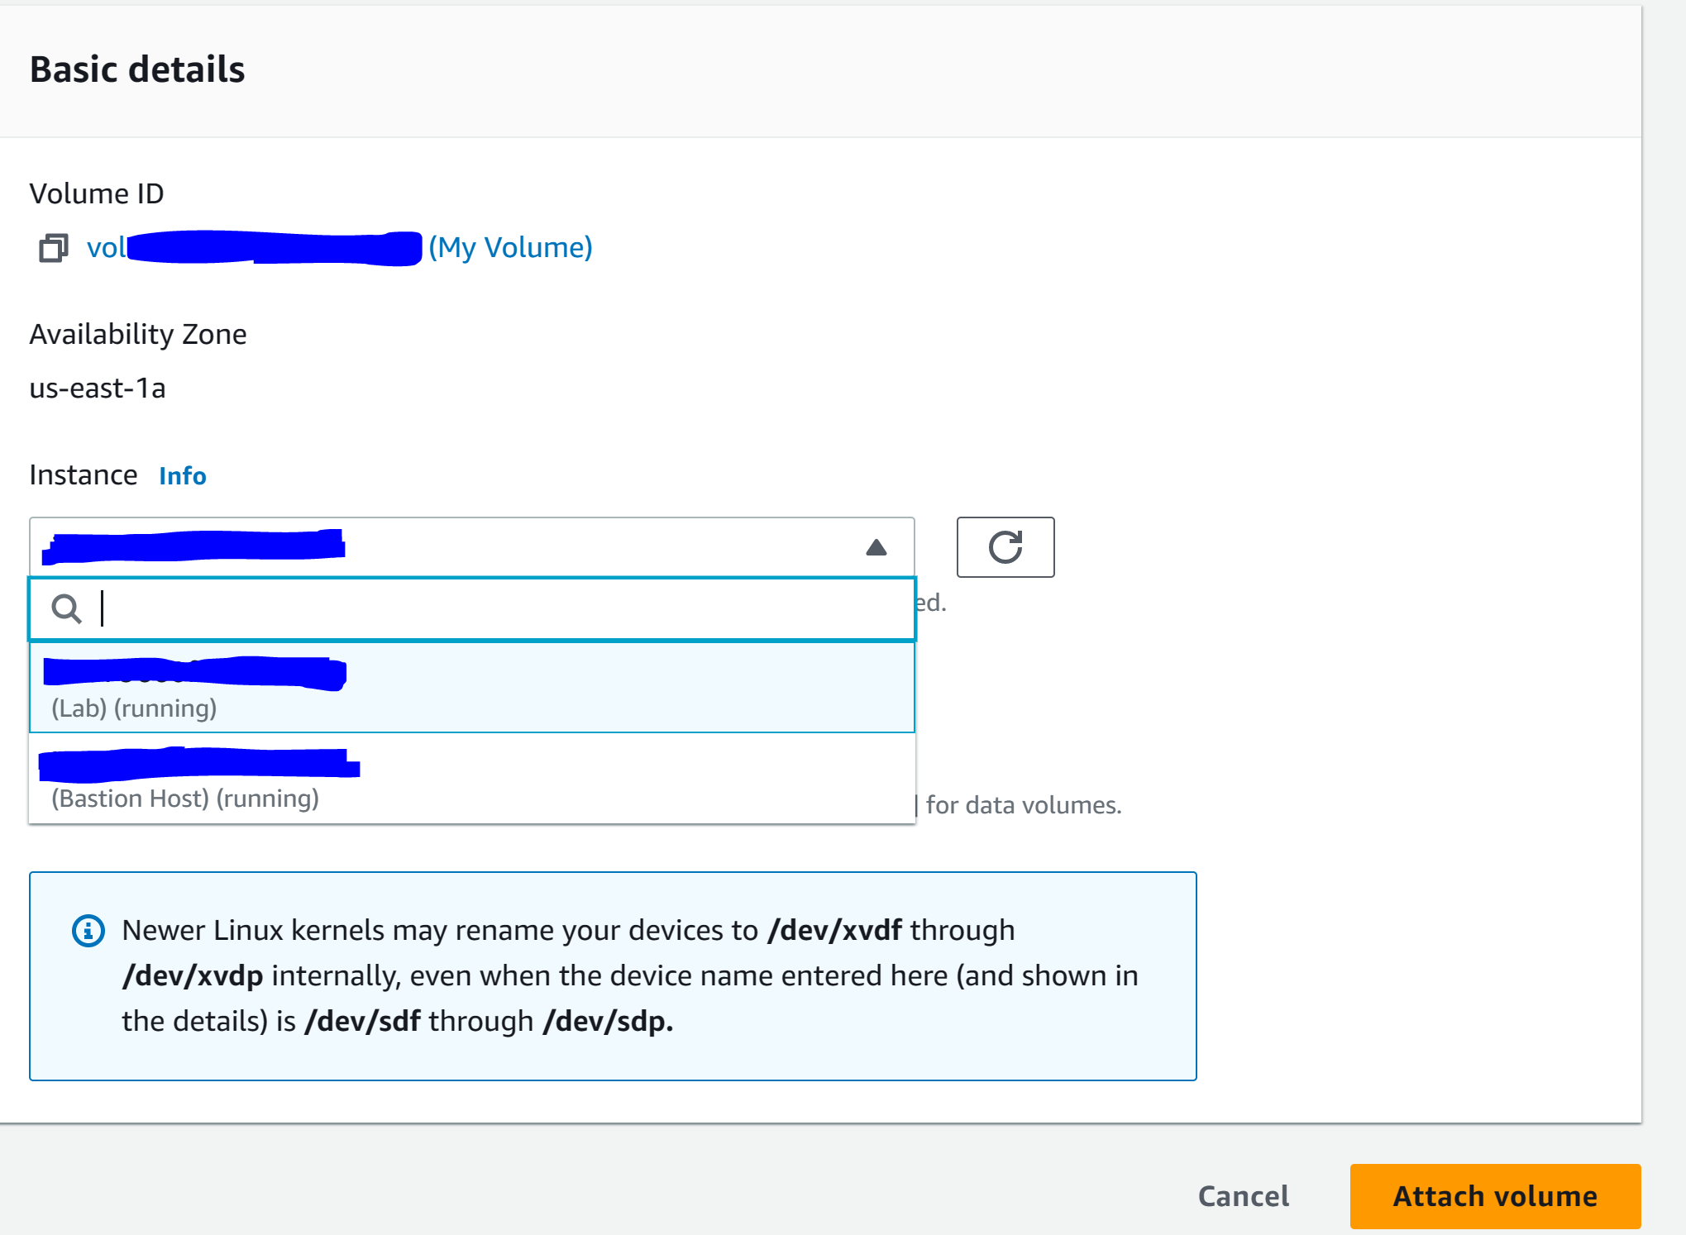

Step 9: Go to Details and Show

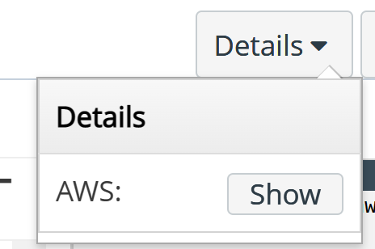

Step 10: click download PPK

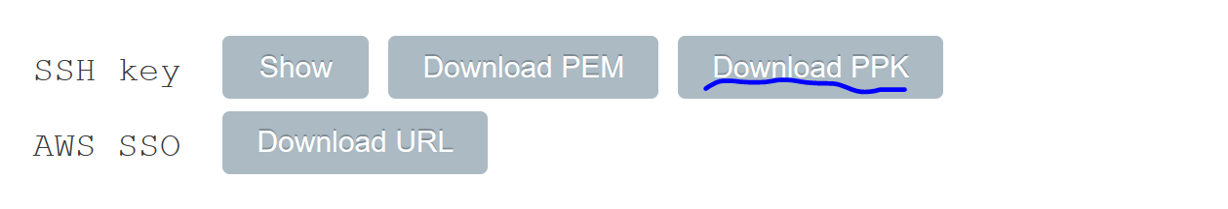

Step 11: Download PuTTy

Step 12: Configure the following in PuTTy

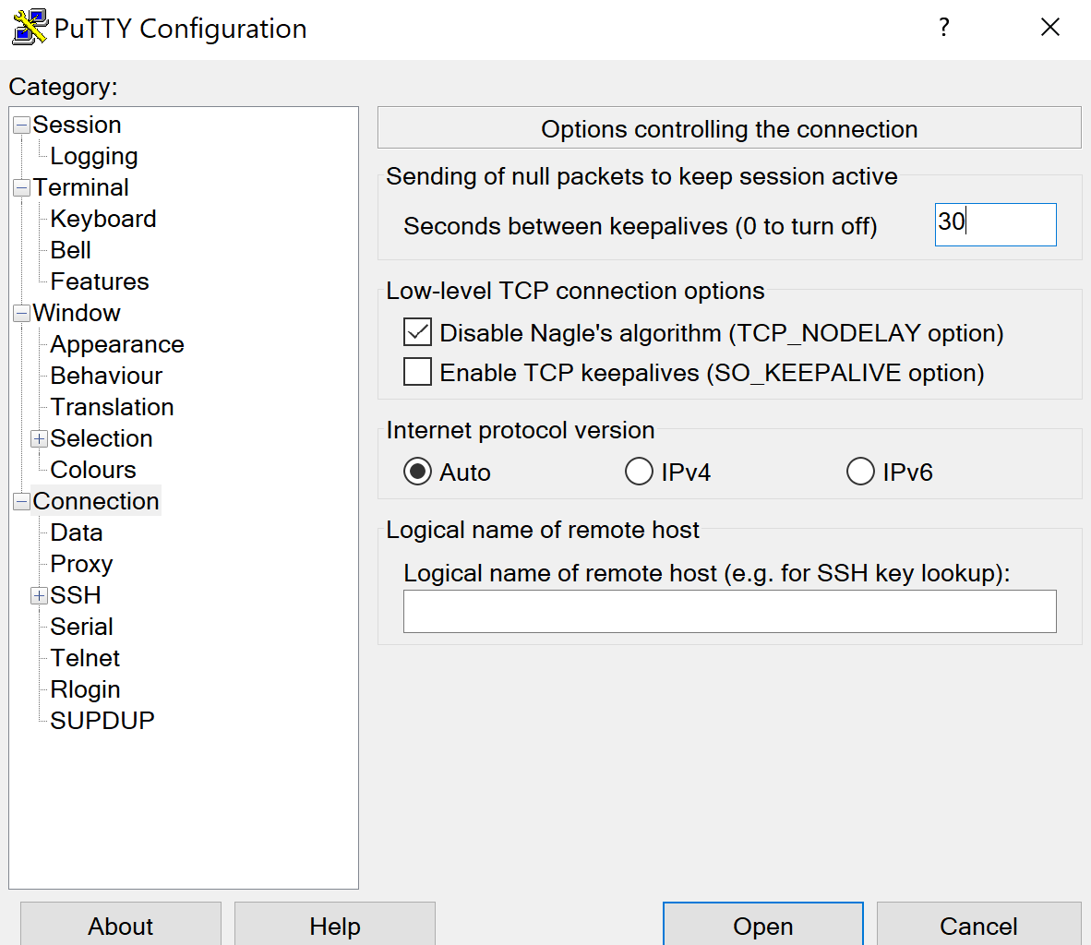

Step 13: paste public IP address of the instance.

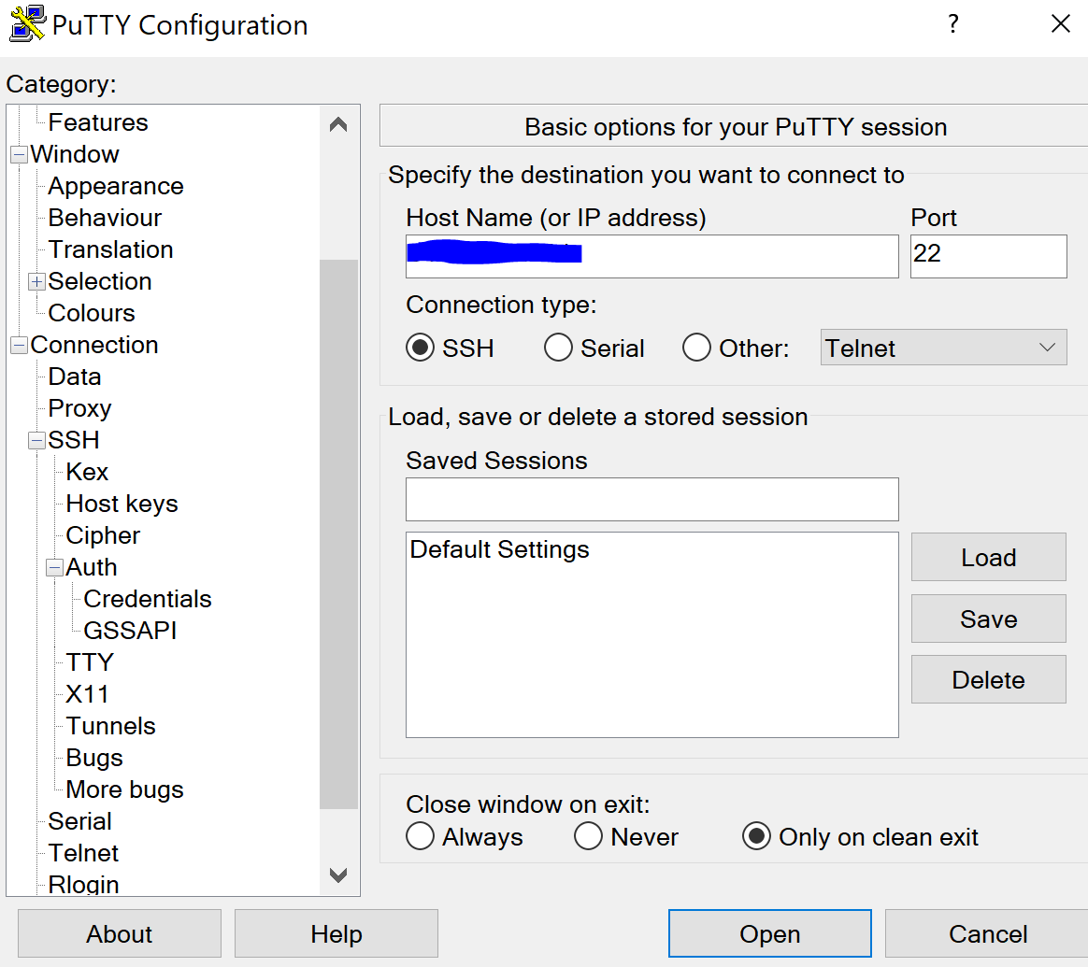

Step 14: Choose the file location of the labuser.ppk file as the key for authentication. Open the connection.

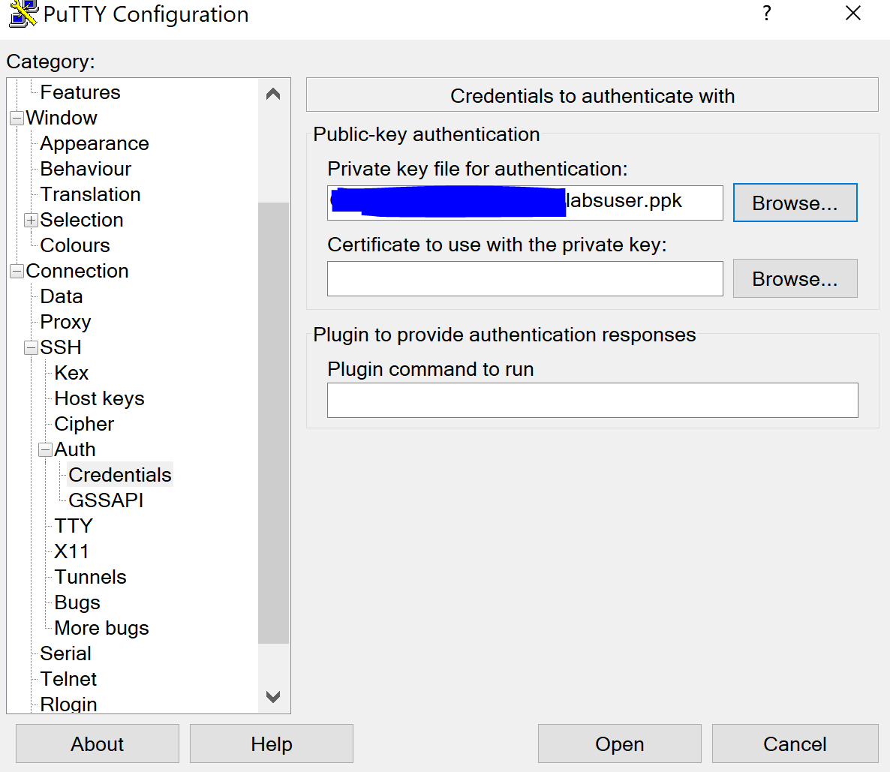

Step 15: log in with the credentials of ec2-user

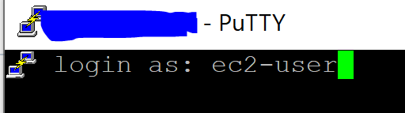

Step 16: use the command df -h to view storage availability on instance

Step 17: create a new ext3 file system on the new volume with the following command: sudo mkfs -t ext3 /dev/sdf

Step 18: create a directory for mounting the new storage volume: sudo mkdir /mnt/data-store

Step 19: mount the new volume with: sudo mount /dev/sdf /mnt/data-store

Step 20: configure mounting of the volume whenever instance is started with: echo “/dev/sdf /mnt/data-store ext3 defaults,noatime 1 2” | sudo tee -a /etc/fstab

Step 21: create a file and add some text to mounted volume with: sudo sh -c “echo some text has been written > /mnt/data-store/file.txt

Step 22: the cat command can be used to view files (e.g. cat /mnt/data-store/file.txt)

Step 23: go to volumes, My Volume, Actions, and create snapshot.

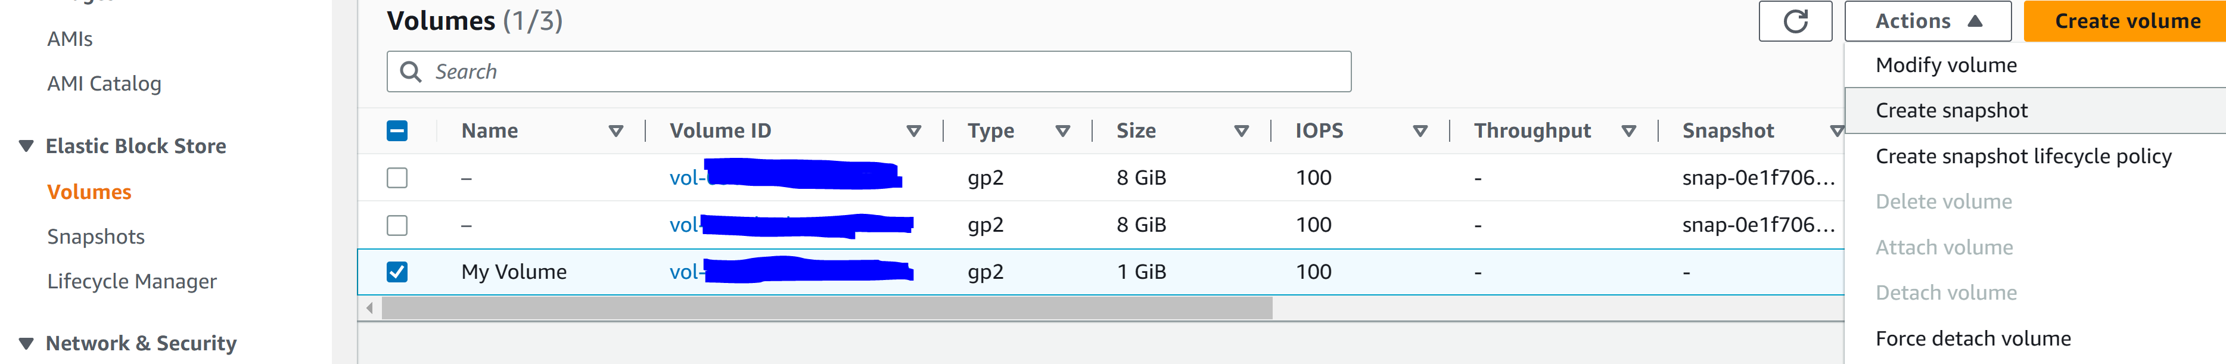

Step 24: Configure the following.

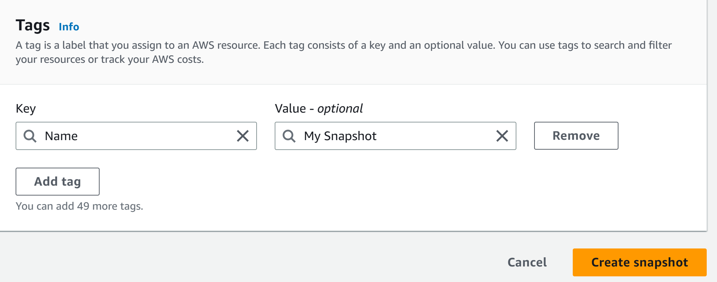

Step 25: delete the text file that was created with: sudo rm /mnt/data-store/file.txt

Step 26: Go to Snapshots, My Snapshot, Actions, and Create Volume from Snapshot

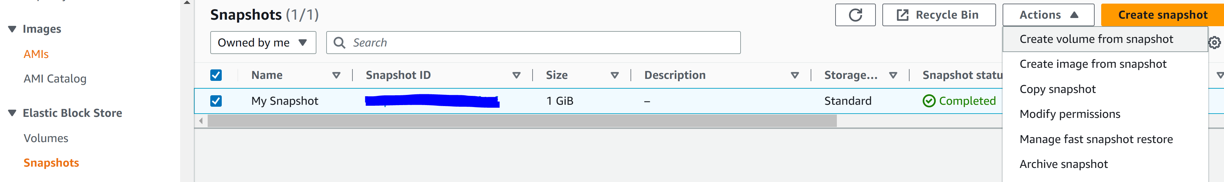

Step 27: Configure the following and select create Volume

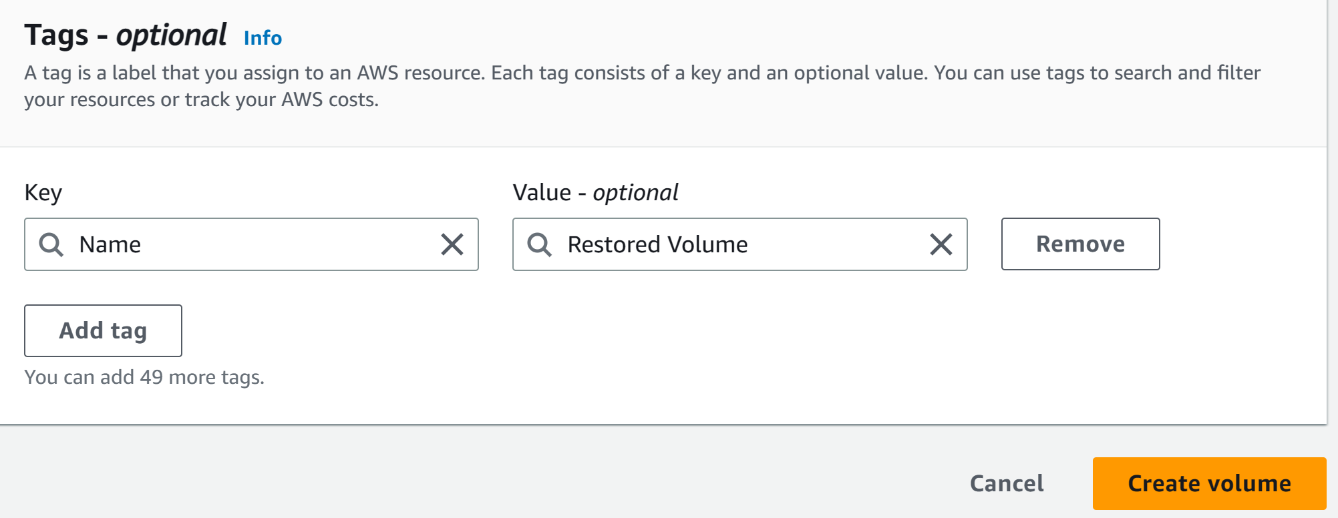

Step 28: Go to Volumes, Restored Volume, Actions, and Attach Volume

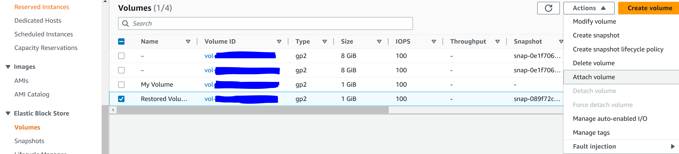

Step 29: Configure the following and click Attach Volume



Step 30: create a directory for mounting the new storage volume: sudo mkdir /mnt/data-store2

Step 31: mount the new volume: sudo mount /dev/sdg /mnt/data-store2

Step 32: verify that the volume you mounted has the file you created earlier and deleted: ls /mnt/data-store2

Step 33: Click End Lab

Amazon Simple Storage Service (Amazon S3) is a object-level storage, which means that if you want to change a part of a file, you must change the entire file. S3 data is stored in resources called buckets. There is almost no limit to amount you can put inside a bucket. There are write, read, and delete functions for objects in buckets. Bucket names are universal and must be unique across the world. Objects can be almost any data file, such as images, videos, or server logs.

There are multiple different Amazon S3 storage classes that are used for different cases.

* Amazon S3 Standard (frequently accessed data)
* Amazon S3 Intelligent-Tiering (automatically move data to the most cost-effective access tier)
* Amazon S3 Standard-Infrequent Access (infrequently accessed data but requires rapid access when needed)
* Amazon S3 One Zone-Infrequent Access (same as Amazon S3 Standard IA but in only one availability zone)
* Amazon S3 Glacier (for data archives)
* Amazon S3 Deep Archive (lowest cost for data archives)

S3 Bucket URLs. To upload data, create a bucket in AWS Region. Upload almost any number of objects to the bucket. Two different types of URLs.

Bucket path-style URL endpoint:

* <https://s3.ap-northeast-1.amazonaws.com/bucket-name>
* Used when you need to access objects.

Bucket virtual-hosted-style URL endpoint:

* <https://bucket-name.s3-ap-northeast-1.amazonaws.com>
* Used when you are using your bucket as a website for static data.

Amazon S3 can be accessed through AWS Management Console, AWS CLI, and SDK. Bucket names need to be DNS compliant so they must be lower case and a combination of letters, numbers, and dashes.

Amazon Elastic File System (Amazon EFS) implements storage for EC2 instances that multiple virtual machines can access at the same time. It is implemented as a shared file system that use the Network File System.

Automatically scale without provisioning. Only pay for storage that is used. EFS is a file storage in the cloud. EFS can be mounted to a VPC.

Five steps to set up EFS.

1. Create your Amazone EC2 resource and launch your Amazon EC2 instance.
2. Create your Amazon EFS file system.
3. Create your mount targets in appropriate subnets
4. Connect your Amazon EC2 instances to the mount targets.
5. Verify the resource and protection of your AWS account.

AWS S3 Glacier is a low cost data archive for long term storage. You cannot immediately retrieve data and may take a few hours. Any object can be archived such as video, image, or document. A vault is a container for storing archives. The vault lock policy ensure that the vault cannot be altered.

Three methods of retrieving data:

* Standard: 3 to 5 hours
* Bulk: 5 to 12 hours (least expensive)
* Expedited: 1-5 minutes (expensive)

Common uses for AWS Glacier include media asset archiving, healthcare information archiving, regulatory and compliance archiving, scientific data archiving, digital preservation, and magnetic tape replacement.

To access data in the Glacier, you can use AWS management console, REST APIs, or Amazon S3 lifecycle policies. Lifecycle polices enable you to delete or move objects based on age.

Billing for Amazon S3 and S3 Glacier are different. You can store an item of up to 40TB in Glacier while only 5TB in S3. You are billed on PUT, COPY, POST, LIST, and GET while you are only billed on UPLOAD and retrieval in Glacier.

Module 8: Databases

Managed vs. unmanaged services.

* Unmanaged services are provisioned in discrete portions. Maintain complete control. Amazon EC2 is an unmanaged service. Benefits include more fine tuned control.
* Managed services require less configuration.

Challenges of relational databases include:

* Server maintenance
* Software installation and patches
* Database backups and high availability
* Limits on scalability
* Data security
* Operating system installation and patches

Manages service that sets up and operates a relational database in the cloud.   
Amazon RDS sets up and scales relational databases without any ongoing administration. With Amazon RDS, you can focus is the data and focus on optimizing your application.

AWS will manage:

* OS installation and patches
* Database software installation and patches
* Database backups
* High availability
* Scaling
* Power, racking, and stacking servers
* Server maintenance

Amazon RDS database instance is a isolated environment. When creating instances, specify which engine to run (mySQL, Amazon Aurora, Microsoft SQL Server, PostgreSQL, MariaDB, Oracle).

Use cases of Amazon RDS include web and mobile applications, ecommerce applications, and mobile games. Use when there are complex transactions or queries, a single worker node, and if you need high durability. Do no use if there is a large amount of read/write rates or high data size.

Amazon RDS billed based on amount of time it is spent running and database characteristics.

**Lab 5: Building a Database Server**

Step 1: click Start Lab

Step 2: click AWS

Step 3: got to services and VPC

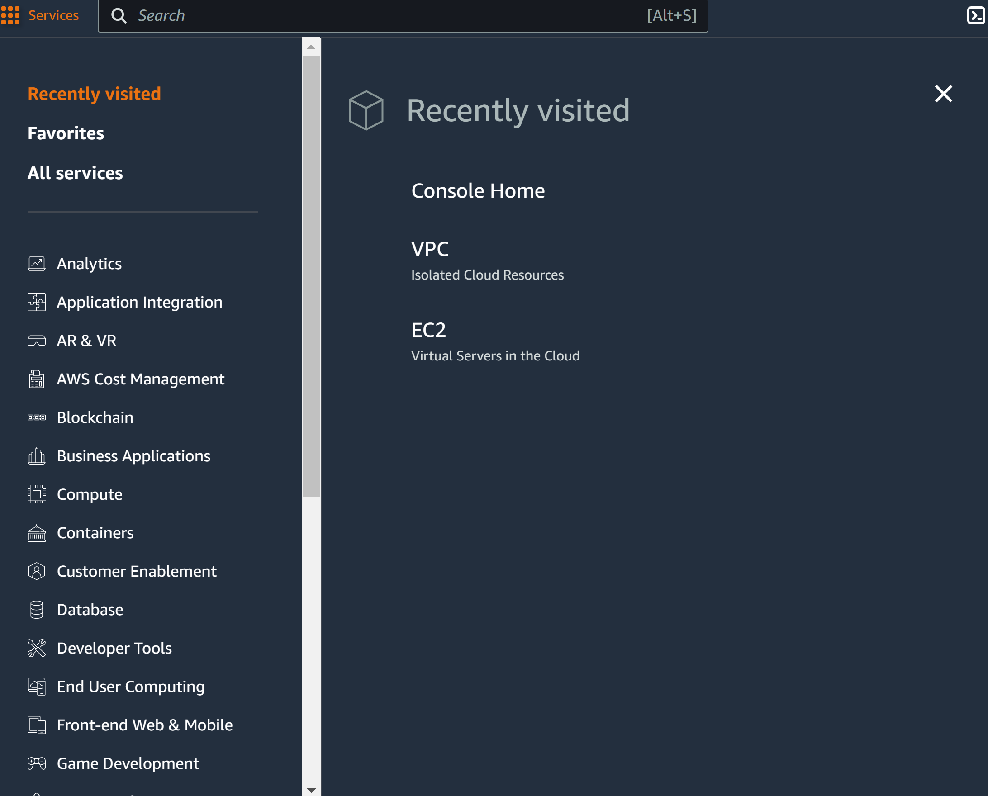

Step 4: got to security groups and create new security group

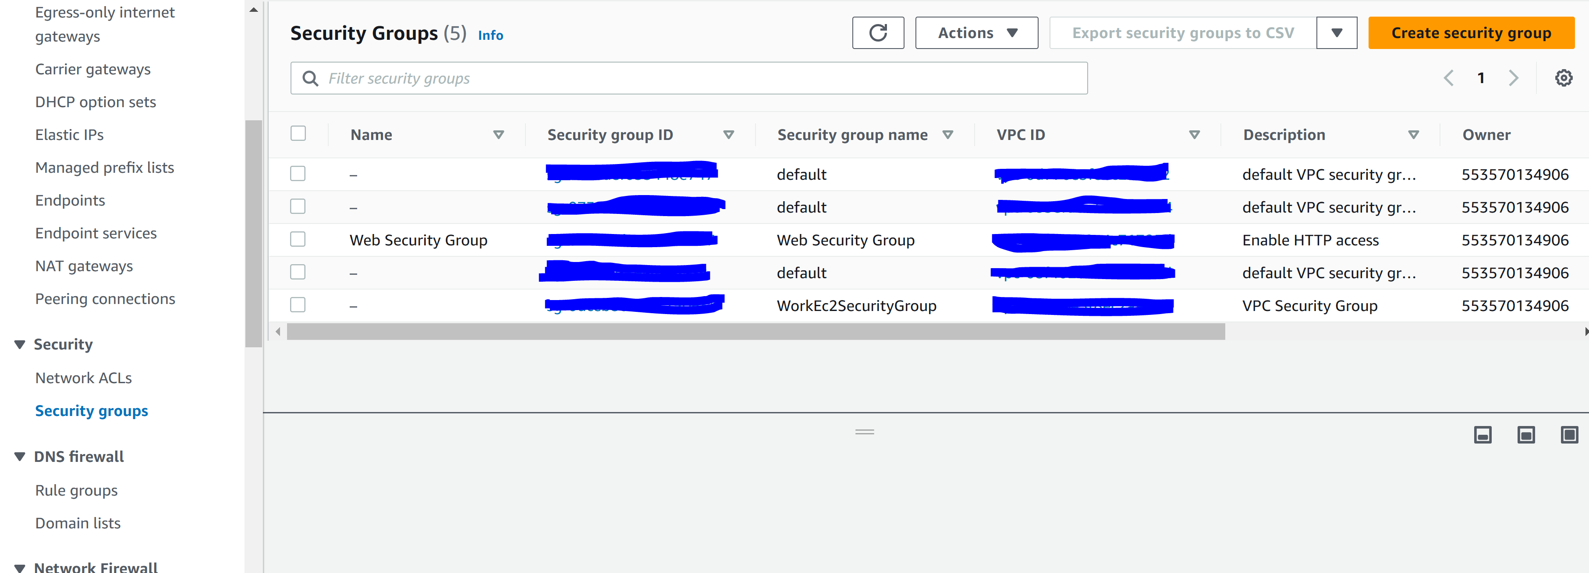

Step 5: Configure the following

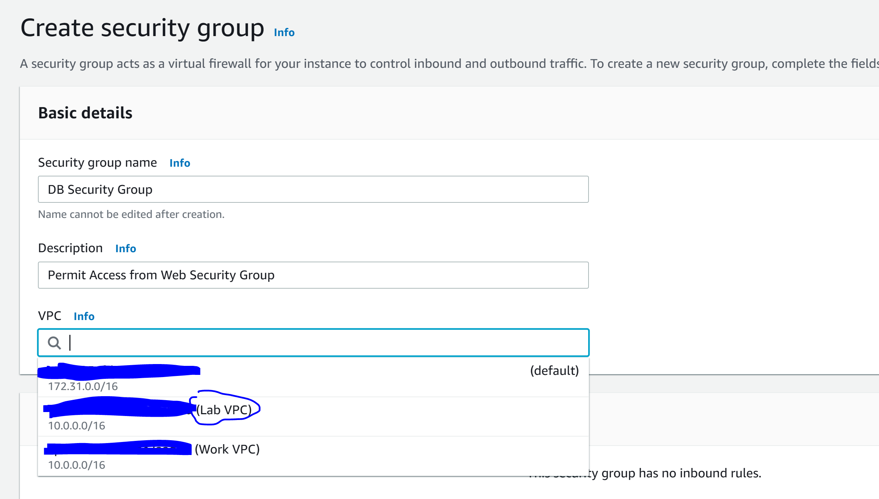

Step 6: Configure the following and click create security group

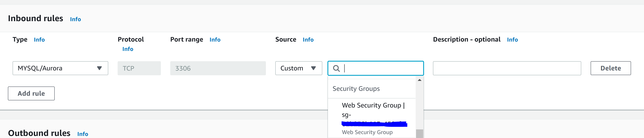

Step 7: Go to Services and RDS

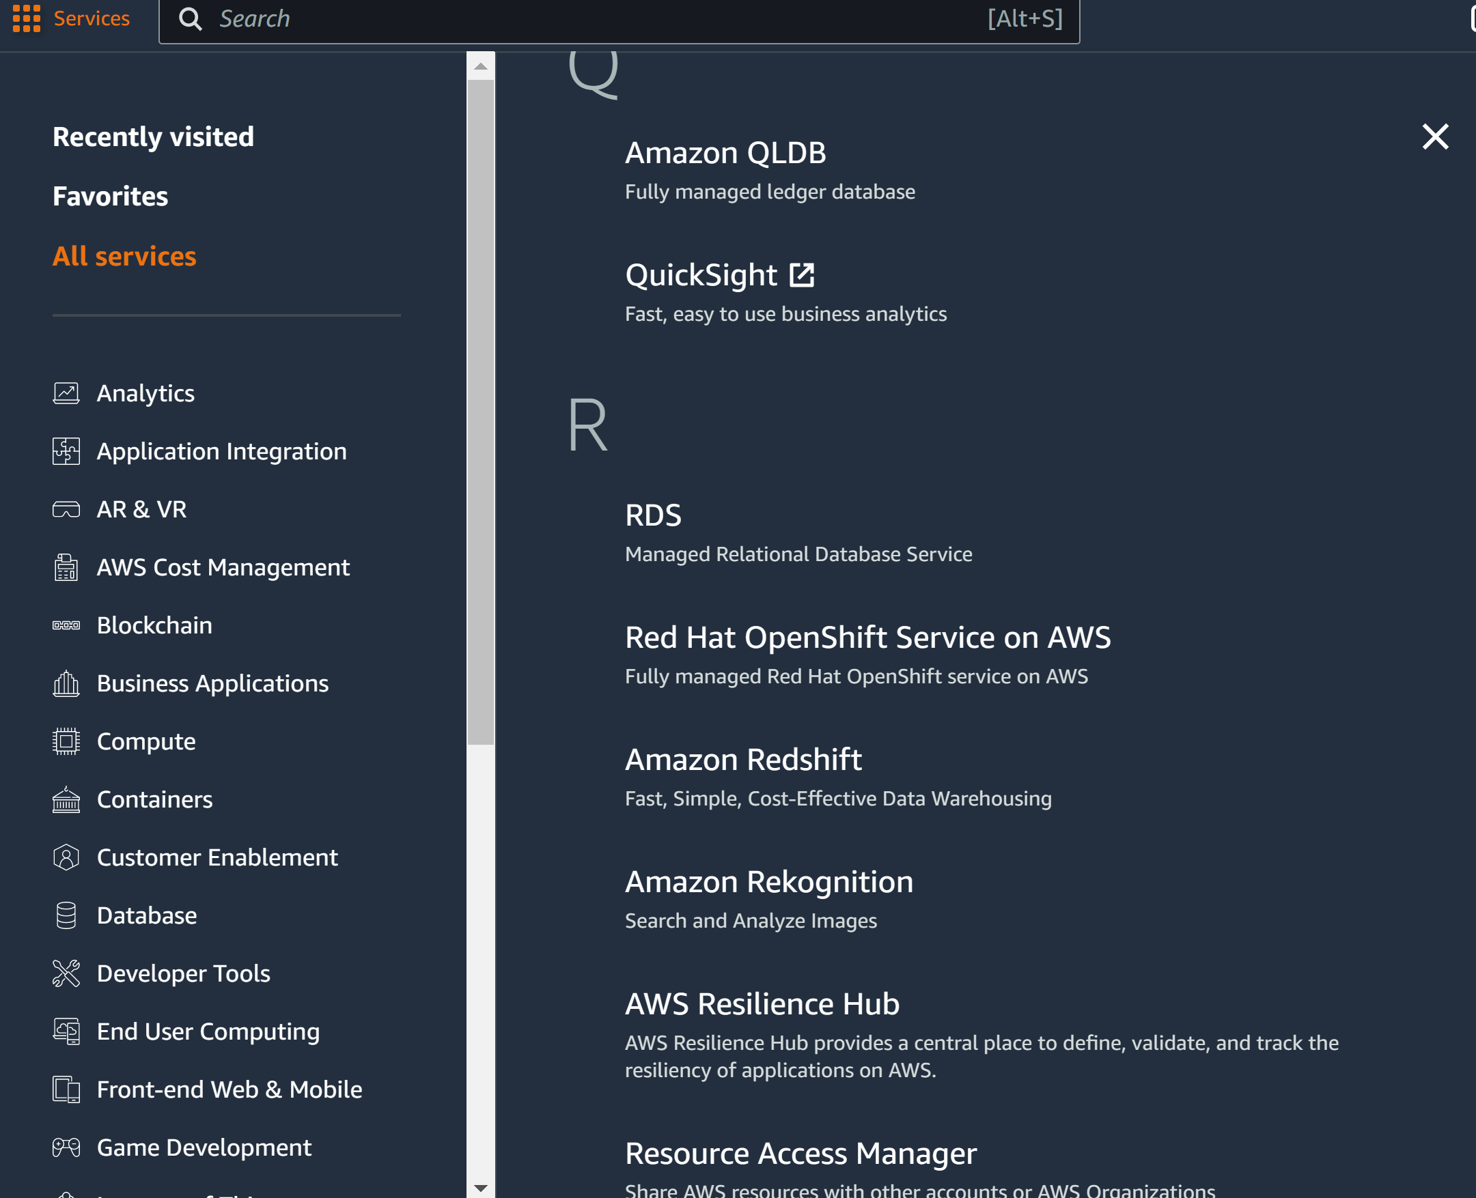

Step 8: go to Subnet Groups and click Create DB Subnet

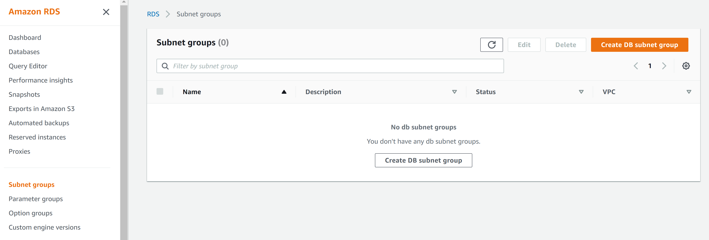

Step 9: configure the following

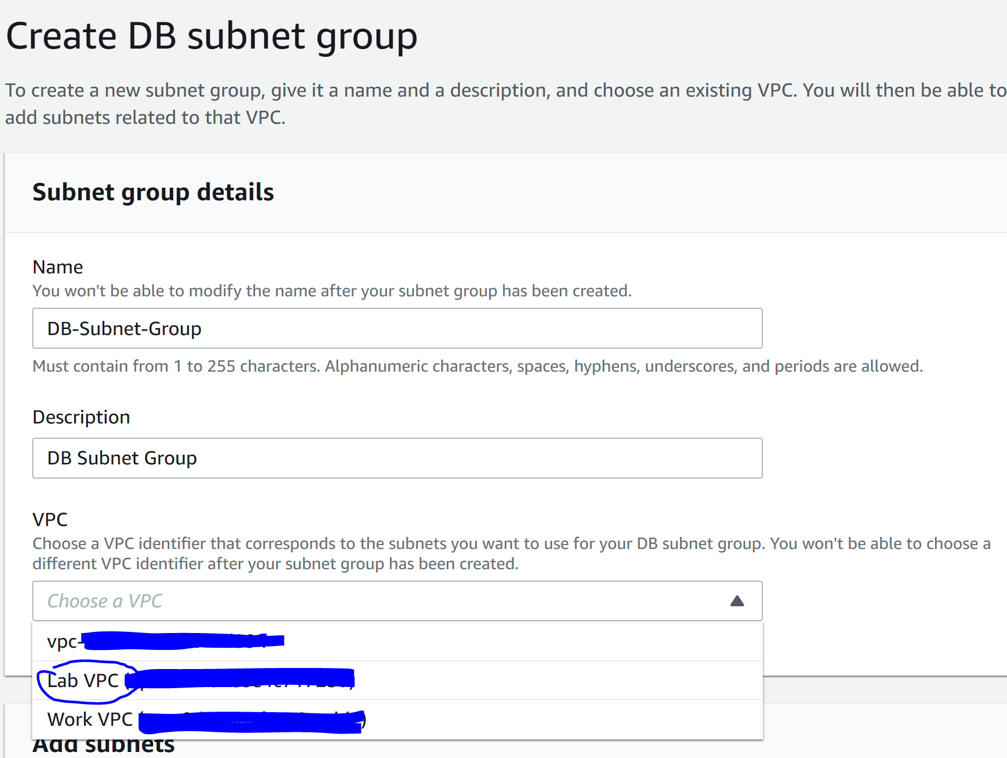

Step 10: configure the following and click create

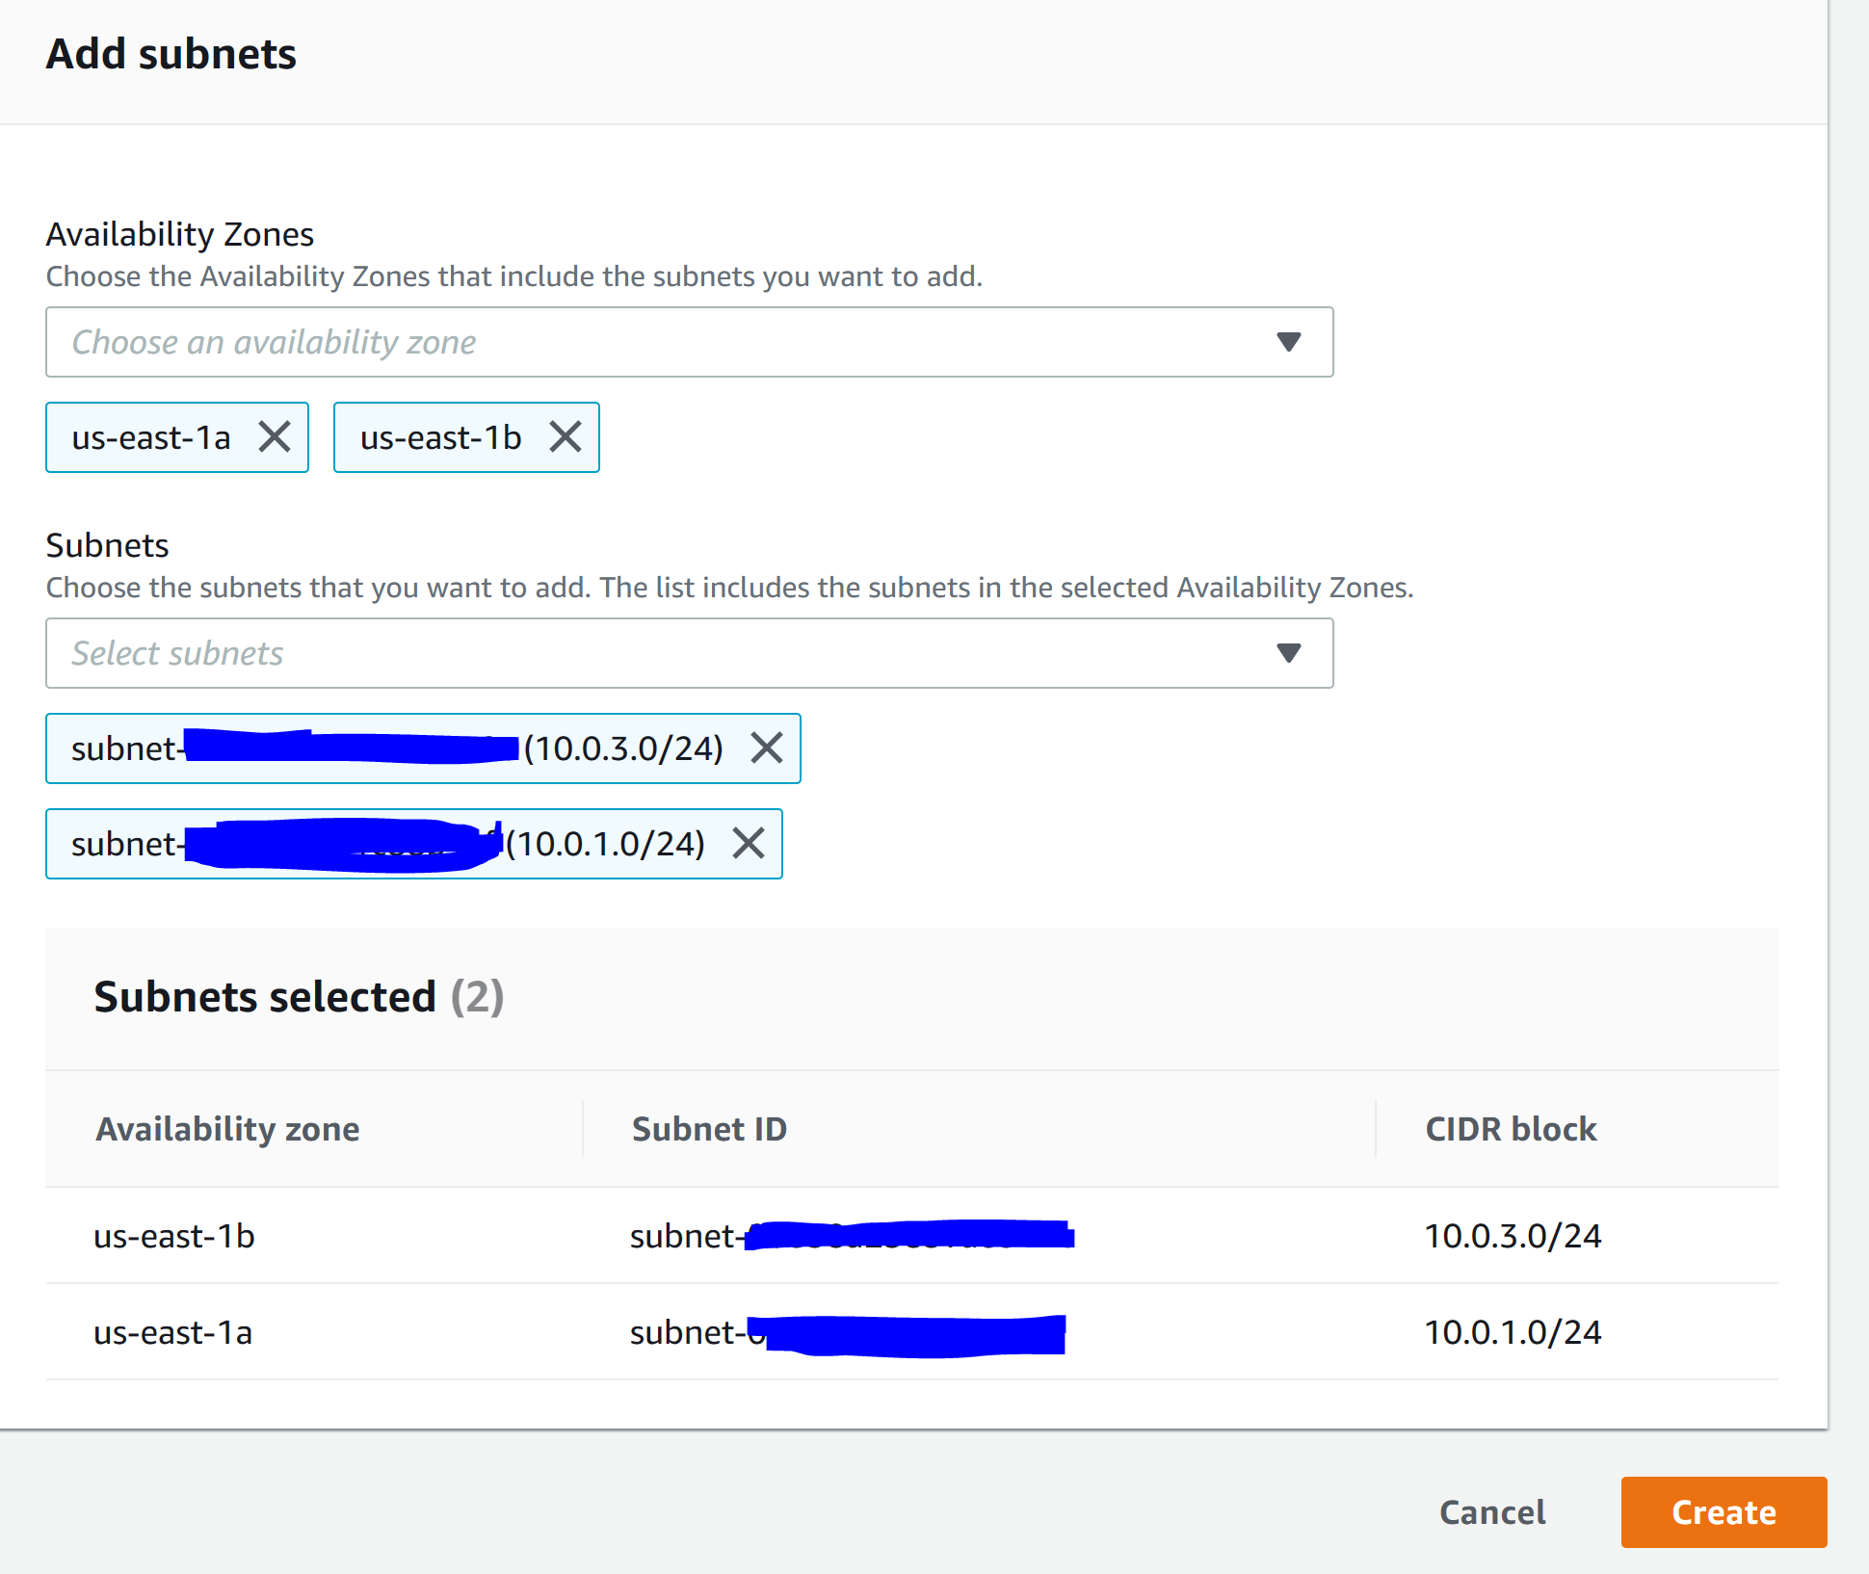

Step 11: Go to Databases and click Create Database

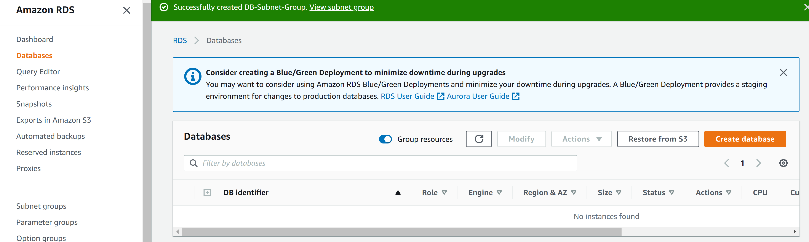

Step 12: configure the following

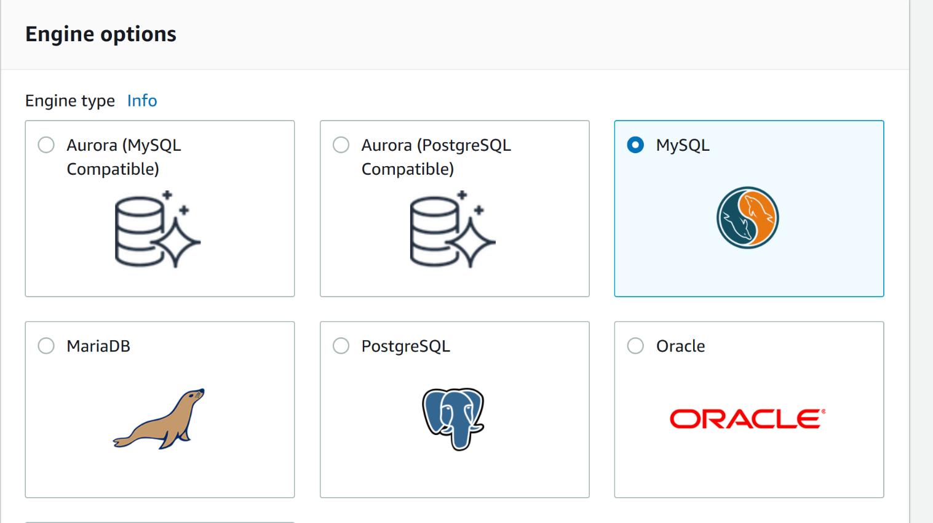

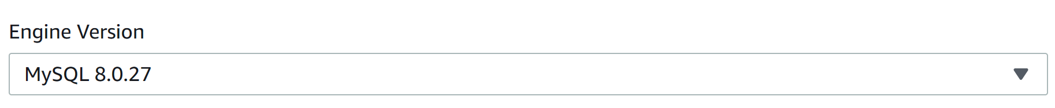

Step 13: configure the following.

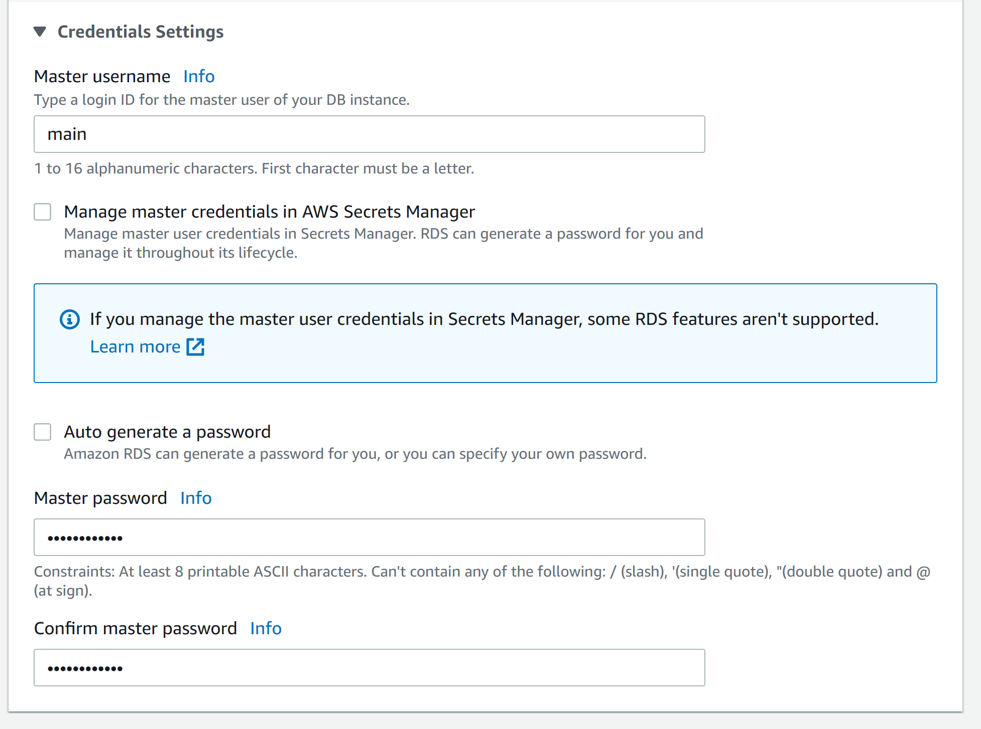

Step 14: configure the following

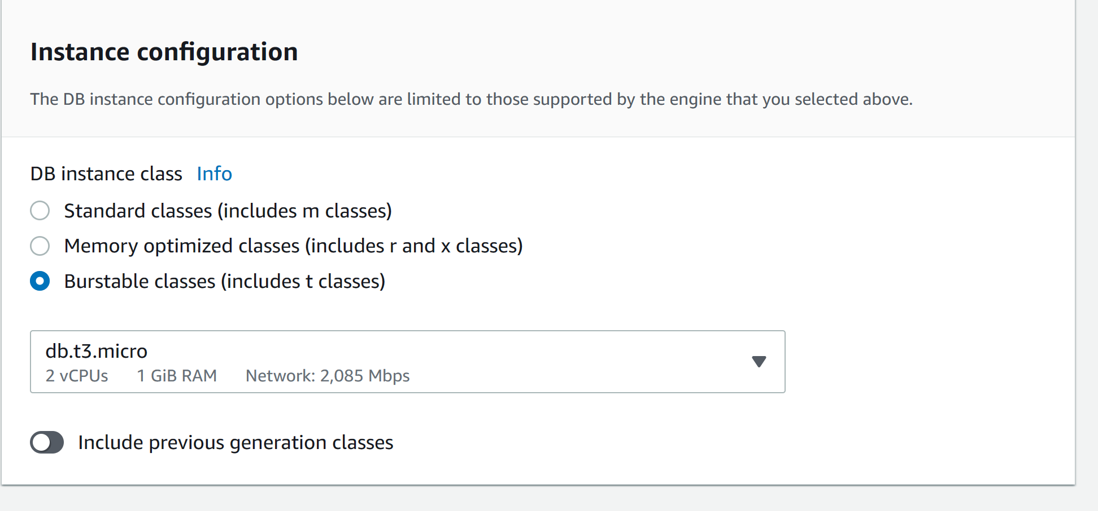

Step 15: configure the following

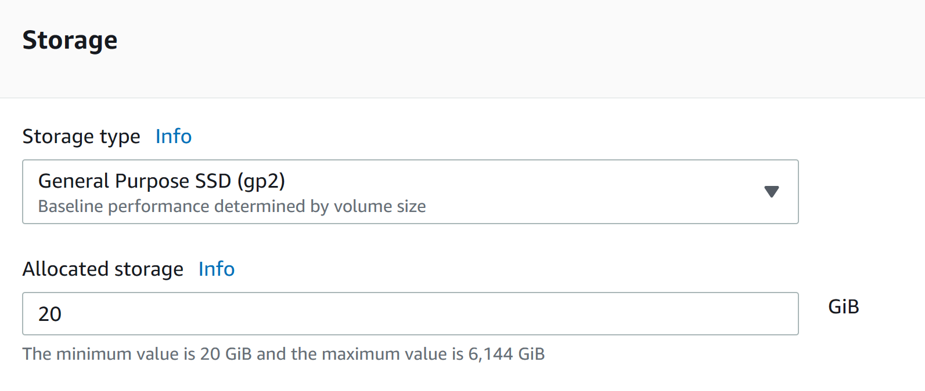

Step 16: configure the following

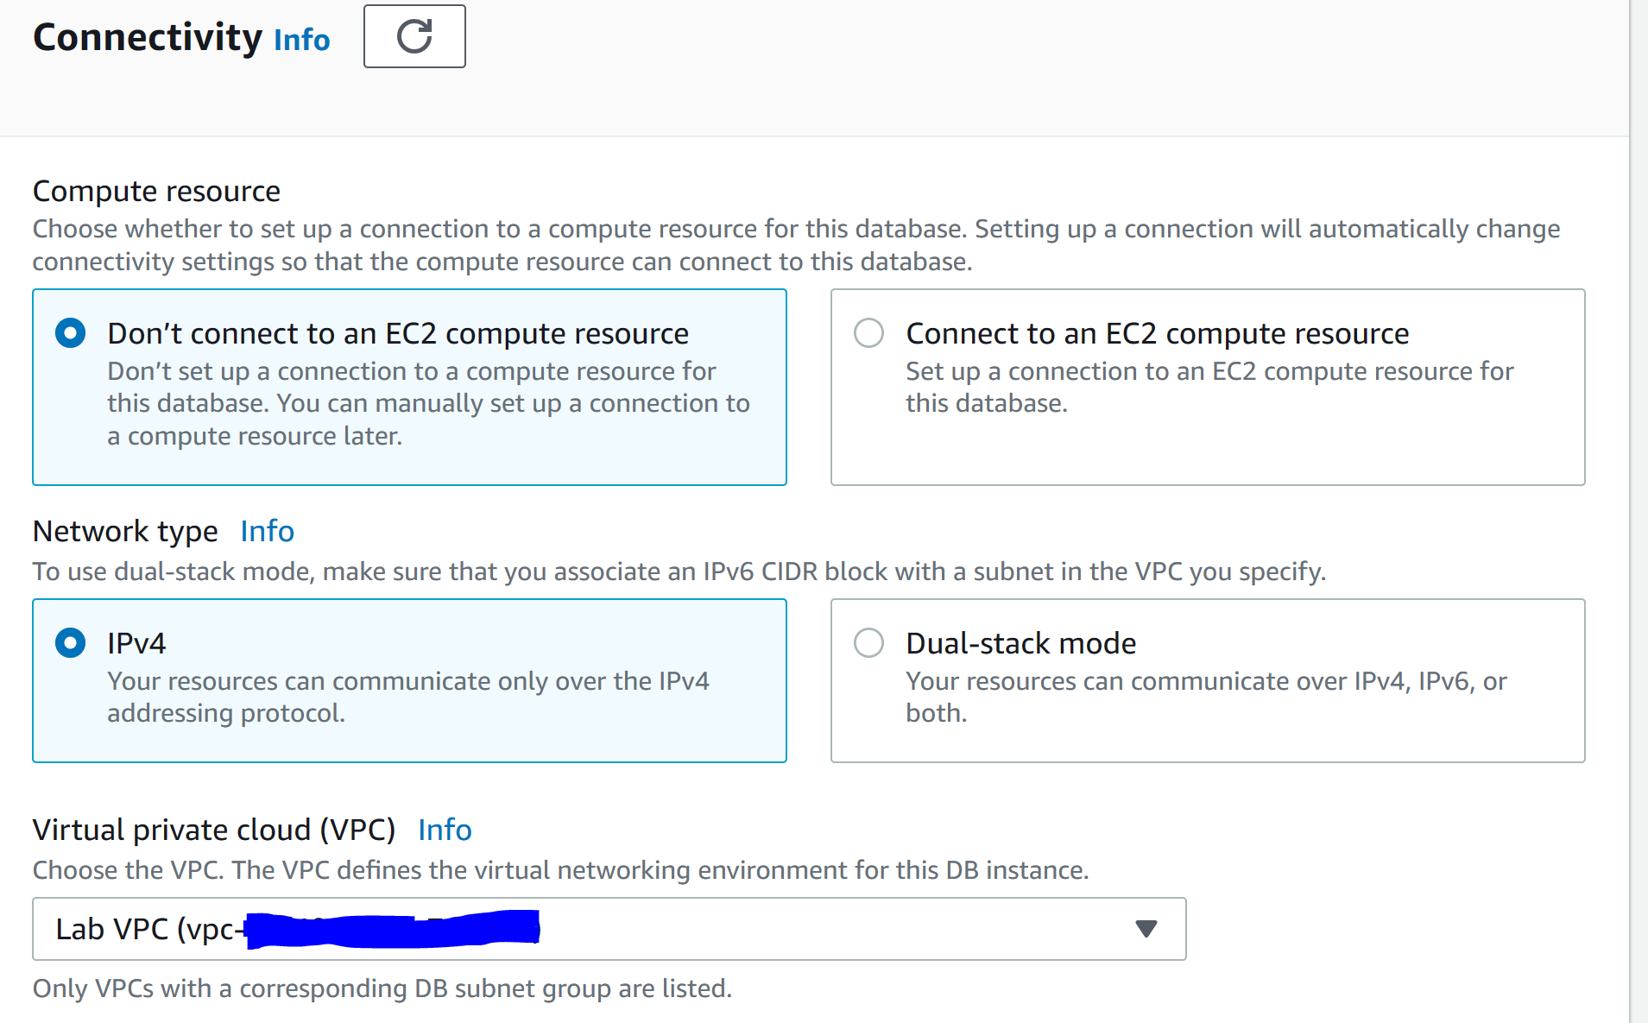

Step 17: configure the following

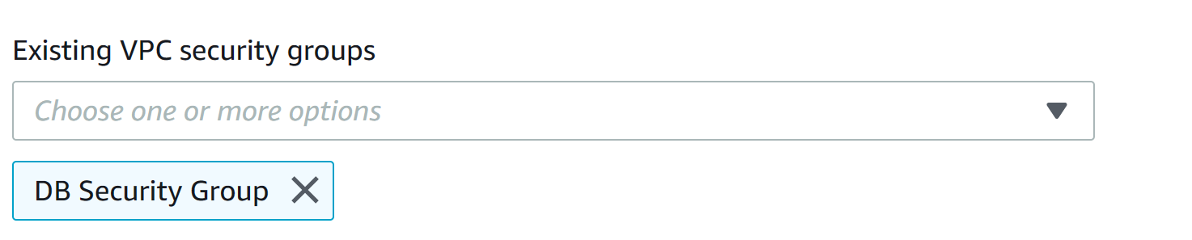

Step 18: configure the following and click create database.

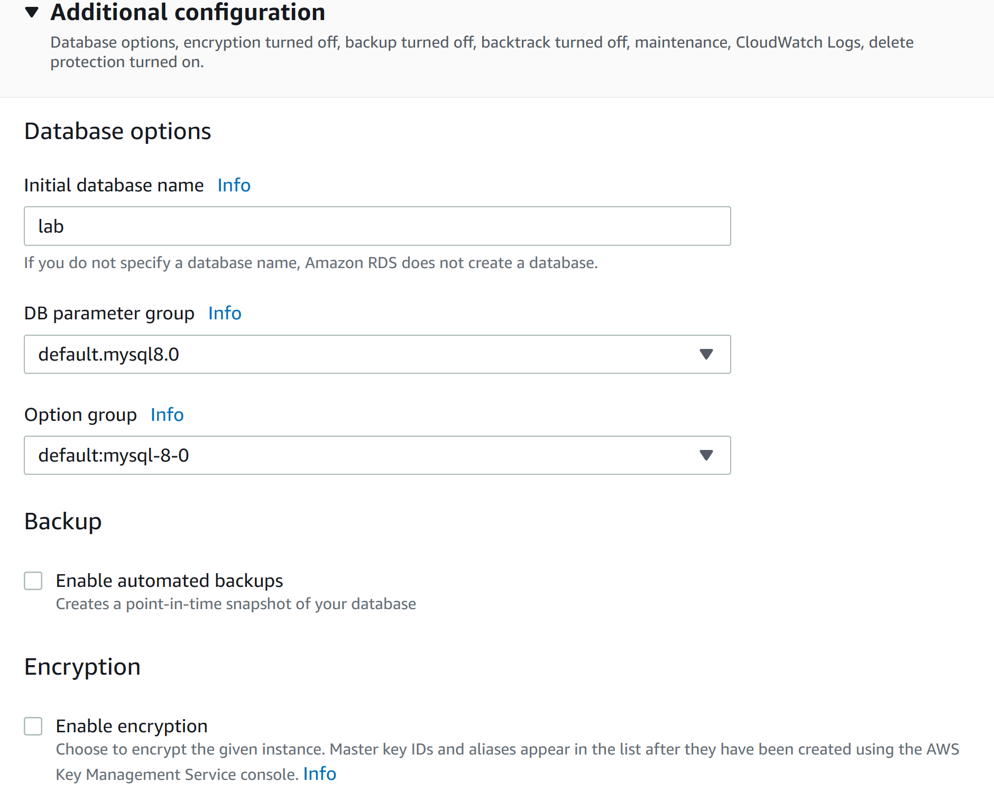

Step 19: go to connectivity and security and copy the endpoint link 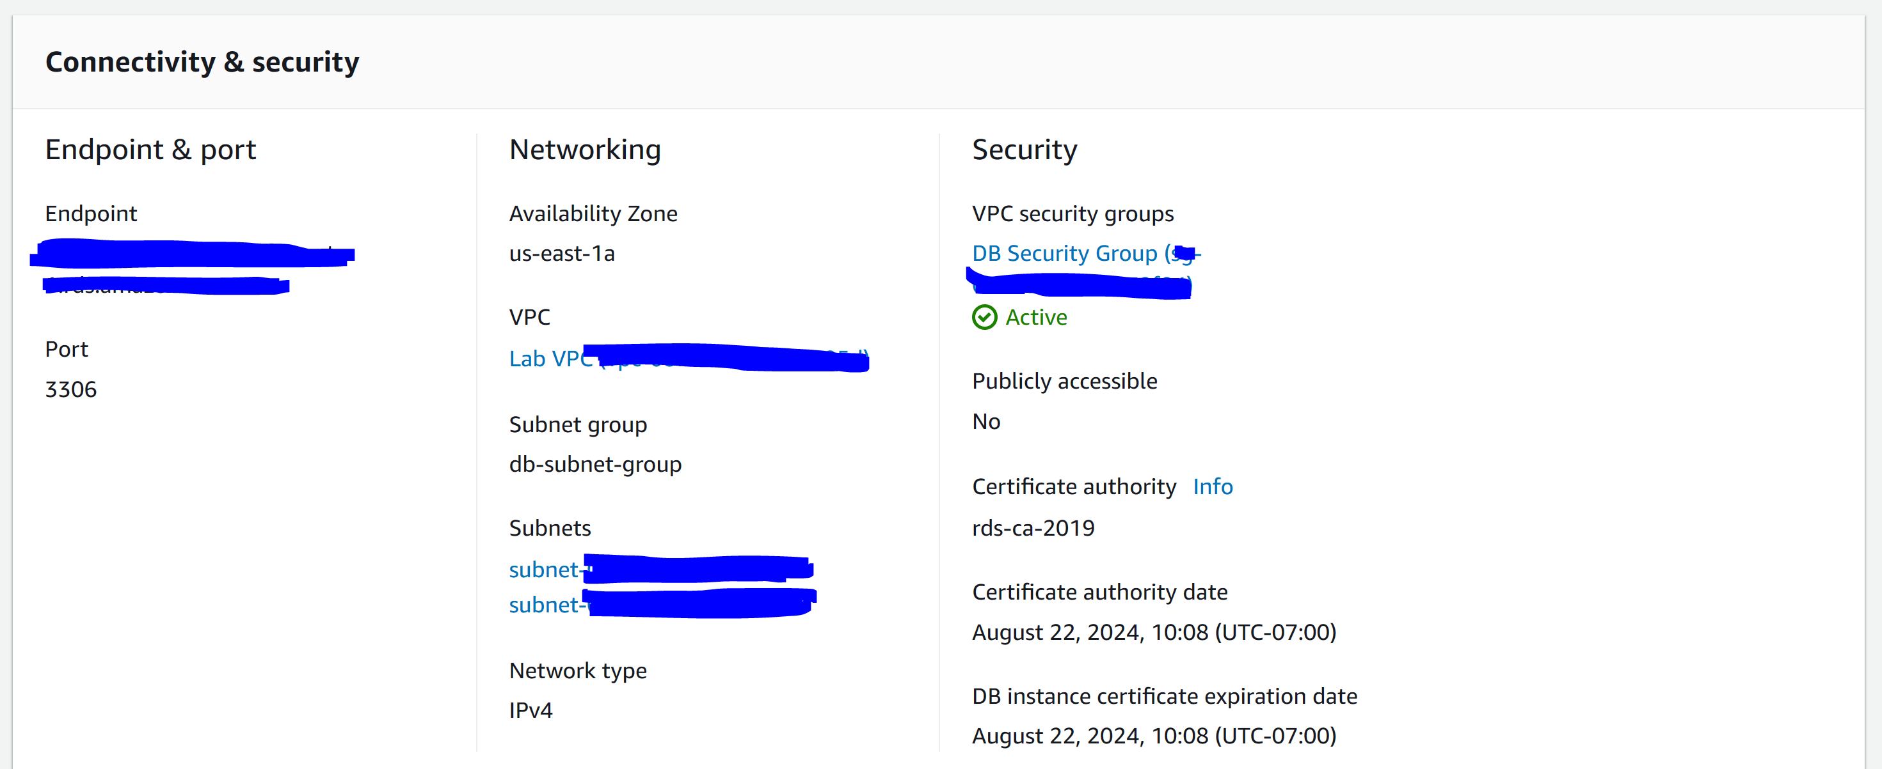

Step 20: go to Details in the AWS instruction site and click show. Open the WebServer IP address.

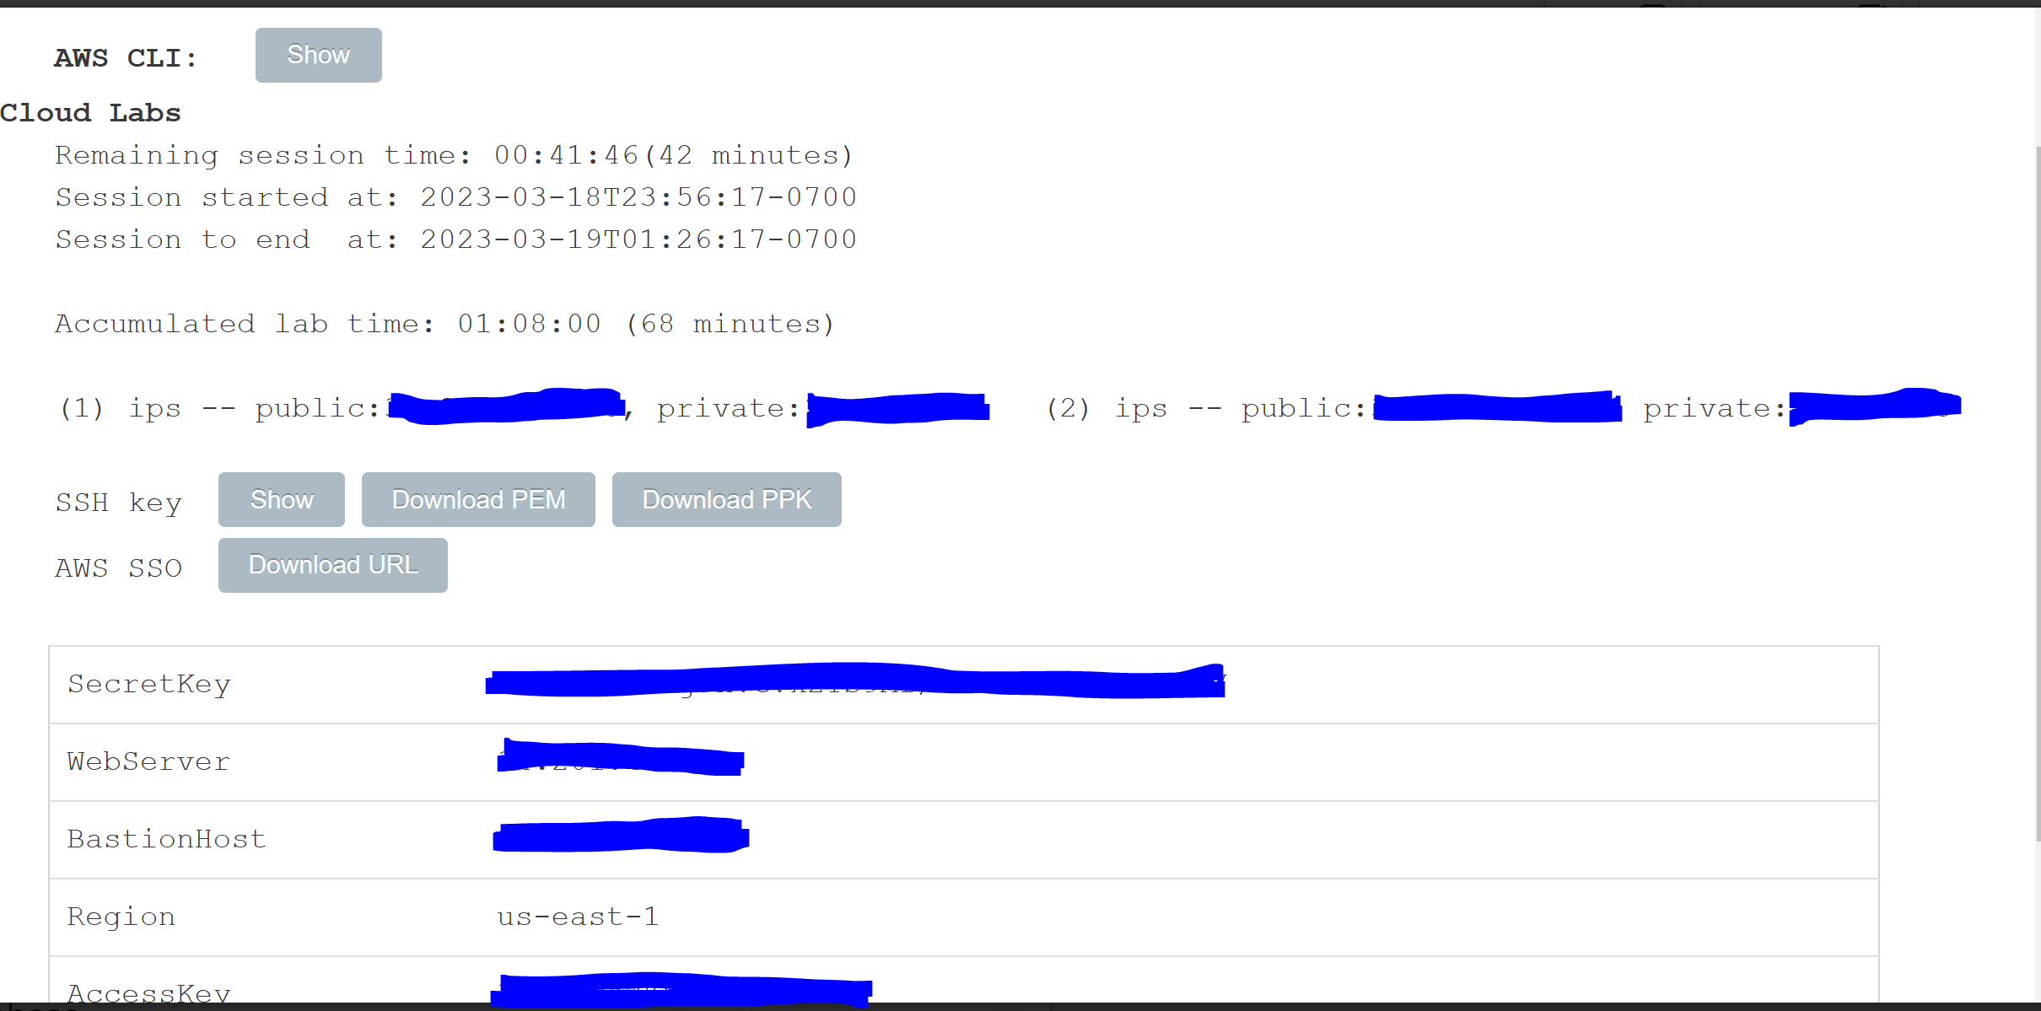

Step 21: go to RDS

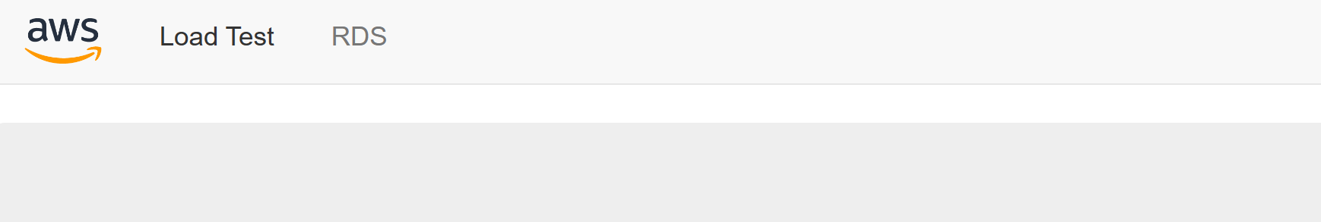

Step 22: configure the following. Remember the endpoint is the link you copied in step 19.

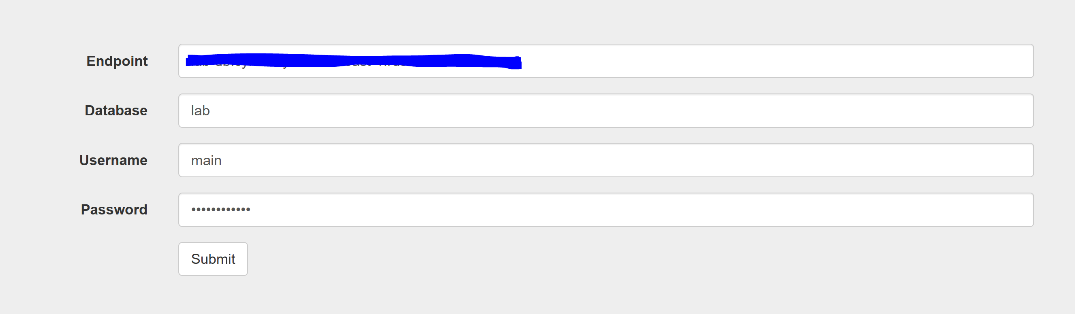

Step 23: you should see the following

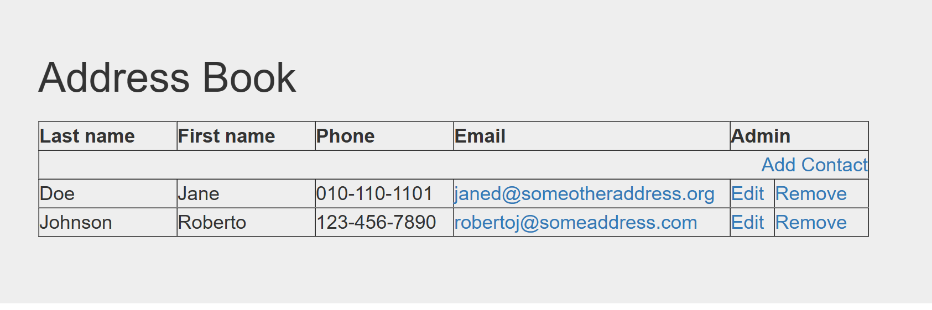

Step 24: click End Lab

Amazon DynamoDB is a non-relational database.

relational databases work with structured data that is organized by tables, records, and columns. You can pull data from multiple tables with queries. Use SQL or structured query language.

Non-relational databases are any databases that do not follow the relational model. Work with lists of key value pairs. Use Java or JSON to document storage data. Good for massive data sets. Also known as NoSQL databases.

Amazon DynamoDB is a NoSQL database for all applications. There is no limit to the amount of data you can store in a table.

Amazon Redshift is fully managed data warehouse that uses SQL. Pay for what you use in Redshift. Management, monitoring, and scaling can be automated. This allows you to focus on the data.

There is security built into Redshift with encryption. Redshift clusters can be connected with other tools.

Common uses of Amazon Redshift include increased agility in warehouses. Good for big data and SaaS customers.

Amazon Aurora is a MySQL and PostgreSQL relational database built for the cloud. Aurora automates time consuming tasks such as provisioning, patching, backup, recovery, failure detection, and repair. Good for large relational database sets.

Pay as you go service. Data is continuously backed up into Amazon S3. Designed for instance crash recovery.

Module 9: Cloud Architecture

Architecture is designing and building large systems or structures. Cloud architects make decisions on the cloud network.

AWS Well-Architected Framework is a guide for designing infrastructure that are secure, high-performing, resilient, and efficient. A way to provide best practices.

Organized into:

* Operational excellence
* Security
* Reliability
* Performance efficiency
* Cost optimization

Operational excellence focuses on running and monitoring systems to deliver business value, and to continually improve supporting processes and procedures. This includes managing and automating changes, responding to events, and defining standards to successfully manage daily operations. Design principles for this pillar include:

* Perform operations as code to reduce human error
* Annotate documentation
* Make frequent, small, reversible changes
* Refine operations procedures frequently
* Anticipate failure
* Learn form all operational events and failures

Security focuses on protecting information, systems, and assets while delivering business value through risk assessment and mitigation strategies. This is done by identifying and managing who can do what, establishing controls to detect security events, protecting systems and services, and protecting confidentiality and integrity of data. Design principles for this pillar include:

* Implement a strong identity foundation
* Enable traceability
* Apply security to all layers
* Automate security best practices
* Protect data in transit and at rest
* Keep people away from data
* Prepare for security events

Reliability focuses on a system’s ability to prevent and quickly recover from failures to meet business and customer demand. This is done in setting up, cross-project requirements, recovery planning, and handling change. Design principles for this pillar include:

* Test recovery procedures
* Automatically recover from failure
* Scale horizontally to increase aggregate system availability
* Stop guessing capacity
* Manage change in automation

Performance efficiency focuses on using IT and computing resources efficiently to meet system requirements and to maintain that efficiency as demand changes and technology evolve. This is done with selecting the right resource types and sizes based on workload requirements, monitoring performance, making informed decisions to maintain efficiency as business needs to evolve. Design principles for this pillar include:

* Democratize advanced technologies
* Go global in minutes
* Use serverless architecture
* Experiment often
* Have mechanical sympathy

Cost optimization focuses on running systems to deliver business value at the lowest price point. This is done with understanding and controlling when money is being spent, selecting the most appropriate and right number of resource types, analyzing spending over time, and scaling to meeting business needs without overspending. Design principles for this pillar include:

* Adopt a consumption model
* Measure overall efficiency
* Stop spending money on data center operations
* Analyze and attribute expenditure
* Use managed and application-level services to reduce cost of ownership

Reliability and availability. Reliability is the measure of your system’s ability to provide functionality when desired by the user. Availability is the time that a system is operating correctly. Defined as a percentage of uptime (e.g. 99.9999%).

A good system can withstand some measurement to degradation while still remaining available. Downtime is minimized and minimal human intervention is required.

Factors that influence availability include:

* Fault tolerance
* Recoverability
* Scalability

AWS Trusted Advisor tool is an online tool that provides real-time guidance to help you provision your resources following AWS best practices. Looks at AWS environment and gives recommendations based on the five categories.

Module 10: Auto Scaling and Monitoring

If there are high demands, additional servers are required. Elastic Load Balancing is an AWS service that distributes incoming application or network traffic across multiple targets.

Three types of load balancers:

* Application load balancer: operates at application level and routes traffic based on content of request. For http or https traffic.
* Network load balancer: operates at the network transport level or layer 4. Routes traffic based on IP protocol data. For TCP and UDP traffic.
* Classic load balancer (previous generation): basic load balancing for multiple EC2 instances. Operates at both application and network level.

Uses for Elastic Load Balancing include:

* High availability and fault-tolerant applications
* Containerized applications
* Elasticity and scalability
* VPC
* Hybrid environments
* Invoke Lambda functions over HTTP(S)

Amazon CloudWatch provides insight on AWS resources. Amazon CloudWatch is a monitoring service that tracks metrics. Alarms can be created to send SMS messages if it is triggered. Alarms can be created on custom metrics.

Targets can include:

* Amazon EC2 Instances
* AWS Lambda Functions
* Kinesis streams
* Amazon ECS tasks
* Step Functions state machines
* Amazon SNS Topics
* Amazon SQS queues
* Built-in targets with CloudWatch events

Pay for what you use.

Create alarms based on a static threshold, anomaly detection, or metric math expressions.

When creating a CloudWatch Alarm, specify:

* Namespace
* Metric
* Statistic
* Period
* Conditions
* Additions configurations
* Actions

Amazon EC2 Auto Scaling. Scaling is the ability to increase or decrease compute capacity of an application. Automatically adds or removes EC2 instances according to conditions.

Scaling can be done manually, on a schedule, or in response to changing demand.

Automatic scaling is good for predictable workloads and on-demand dynamic workloads. Idle groups are groups of Amazon EC2 instances that are treated as a logical grouping.

Launching more instances is known as scaling out while terminating instances is known as scaling in.

AWS uses machine learning to predict expected traffic.

Types of scaling include:

* Maintain current number
* Manual scaling
* Scheduled scaling
* Dynamic scaling
* Predictive scaling (auto scaling)

Amazon EC2 Auto Scaling works well with Amazon CloudWatch. Have CloudWatch monitor CPU usage and trigger alarms to run automatic scaling policies.

**Lab 6 – Scale and Load Balance your Architecture**

Step 1: Click Start Lab

Step 2: Click AWS

Step 3: Go to services and EC2

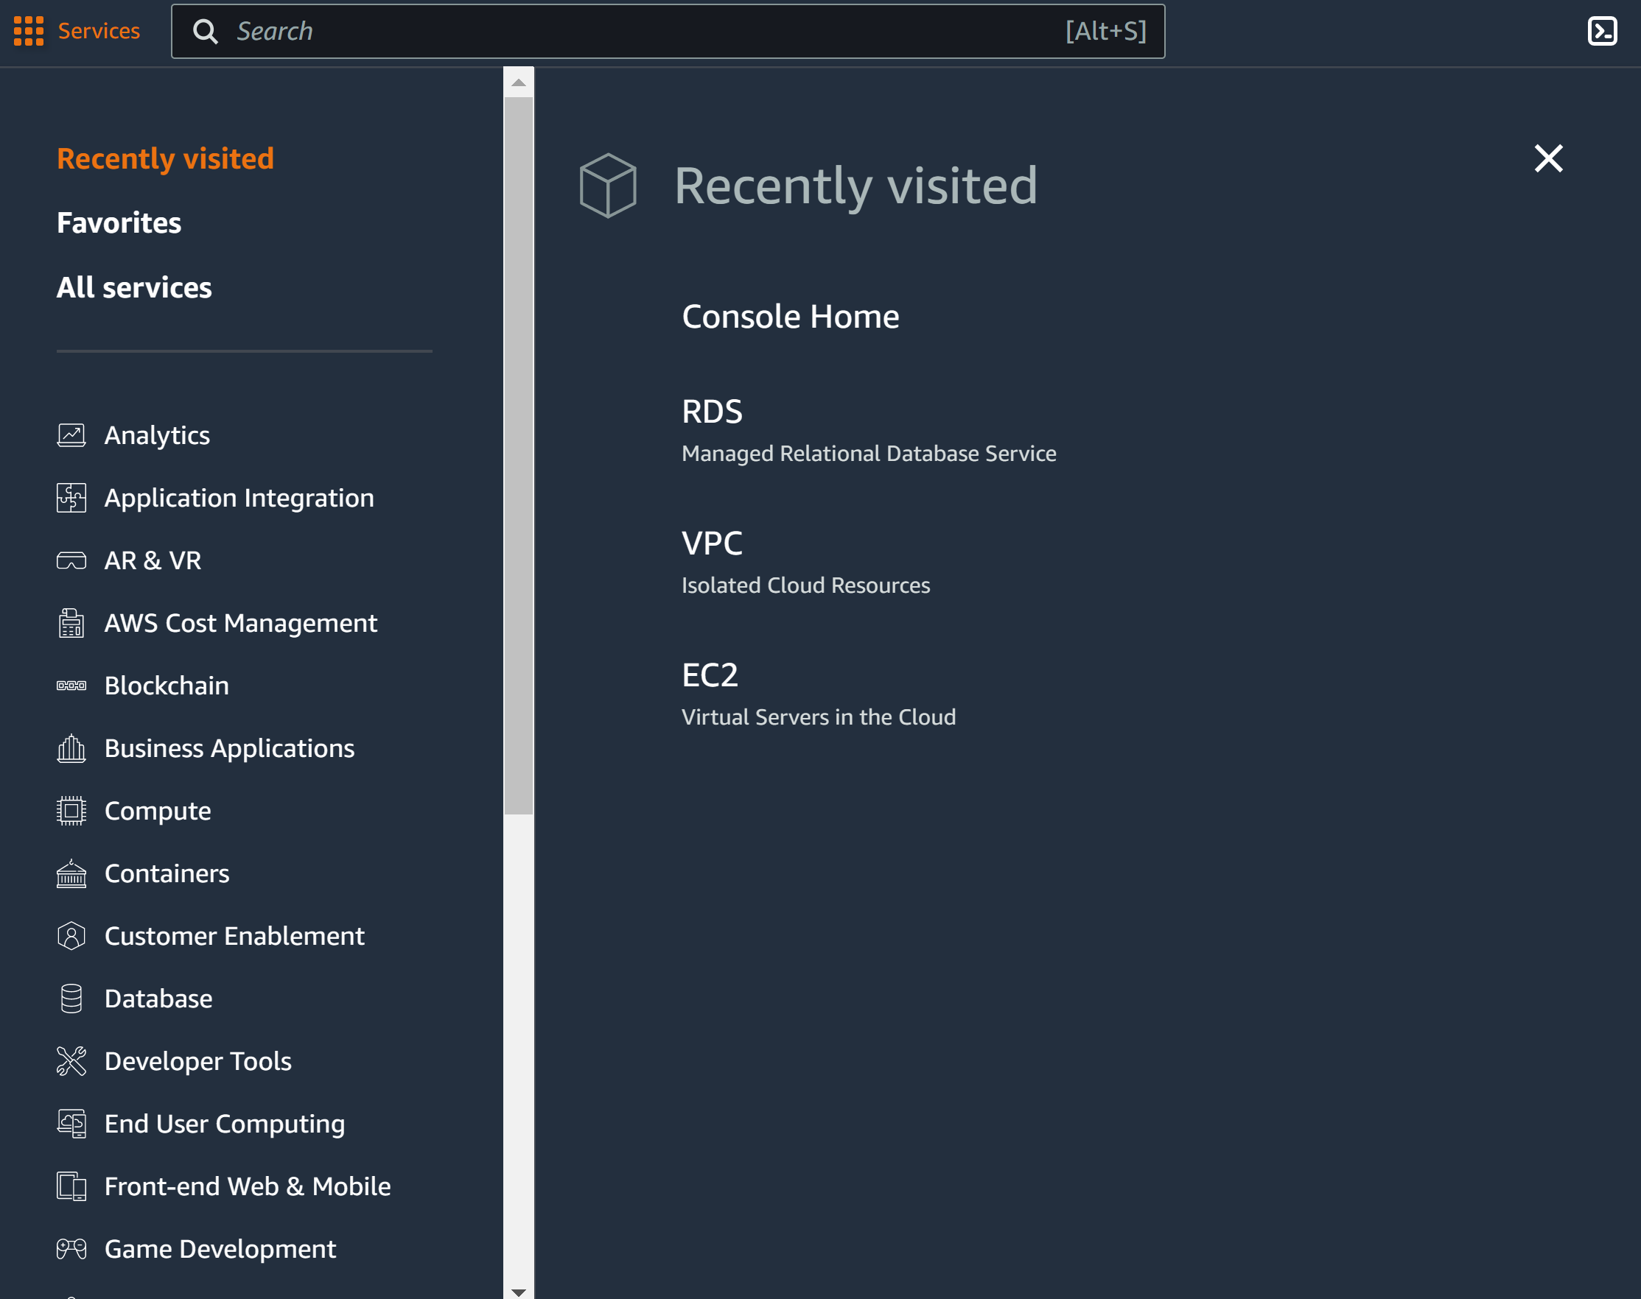

Step 4: go to instances. Click web server 1. Go to actions, images and templates, and create image

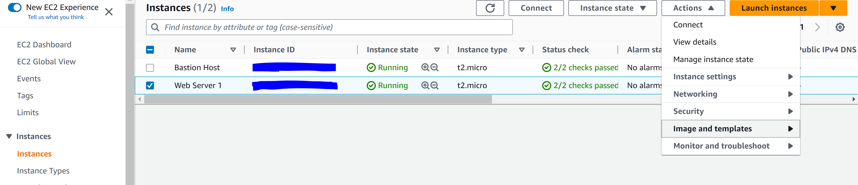

Step 5: configure the following and create image

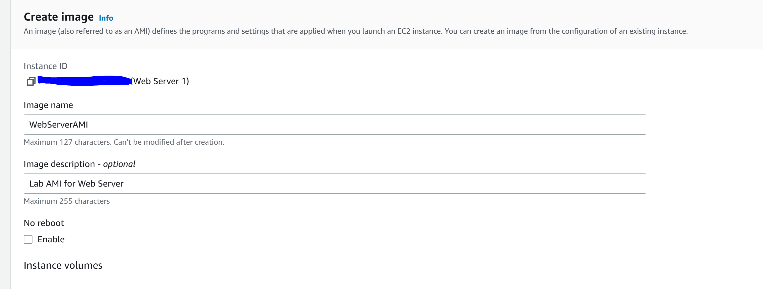

Step 6: go to Target Groups and click Create target group

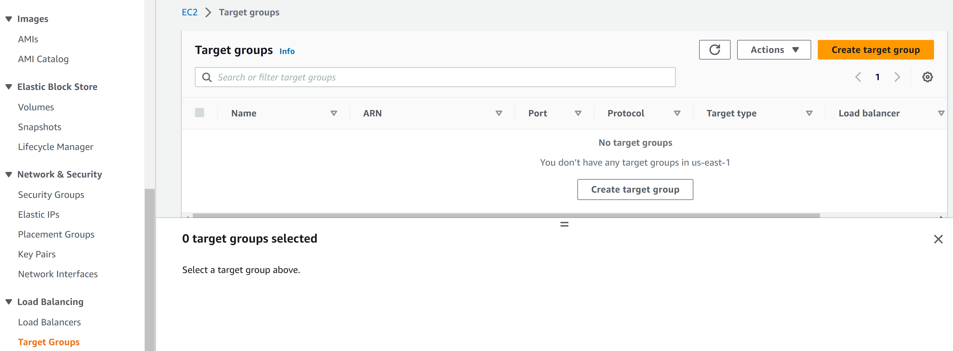

Step 7: configure the following

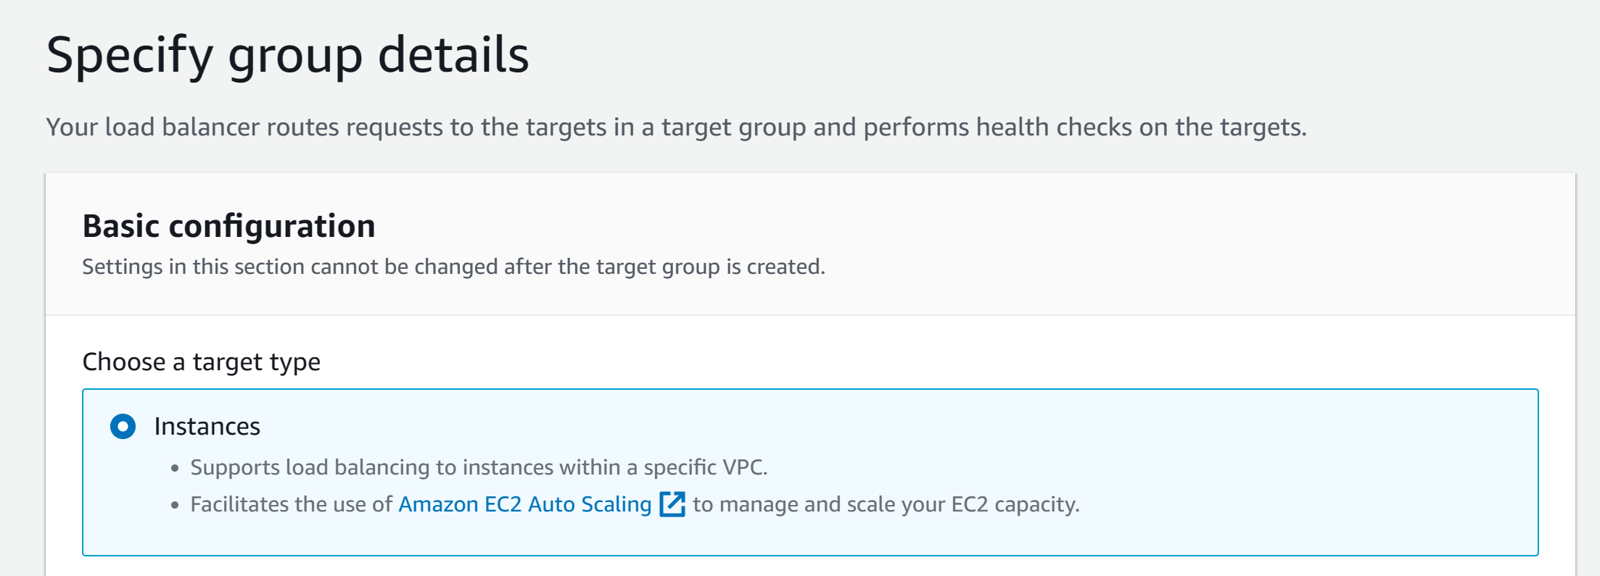

Step 8: configure the following. Click Next and then click Create target group

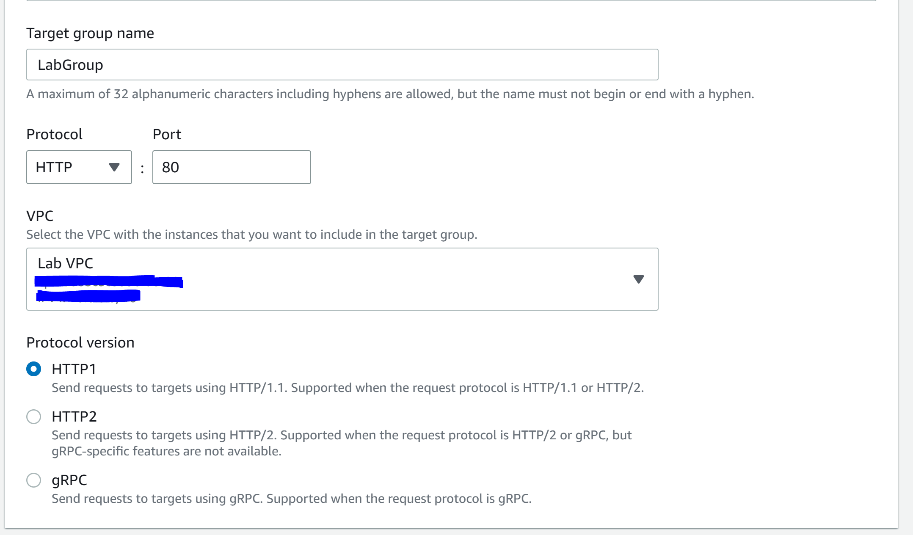

Step 9: go to Load Balancers and click Create load balancer

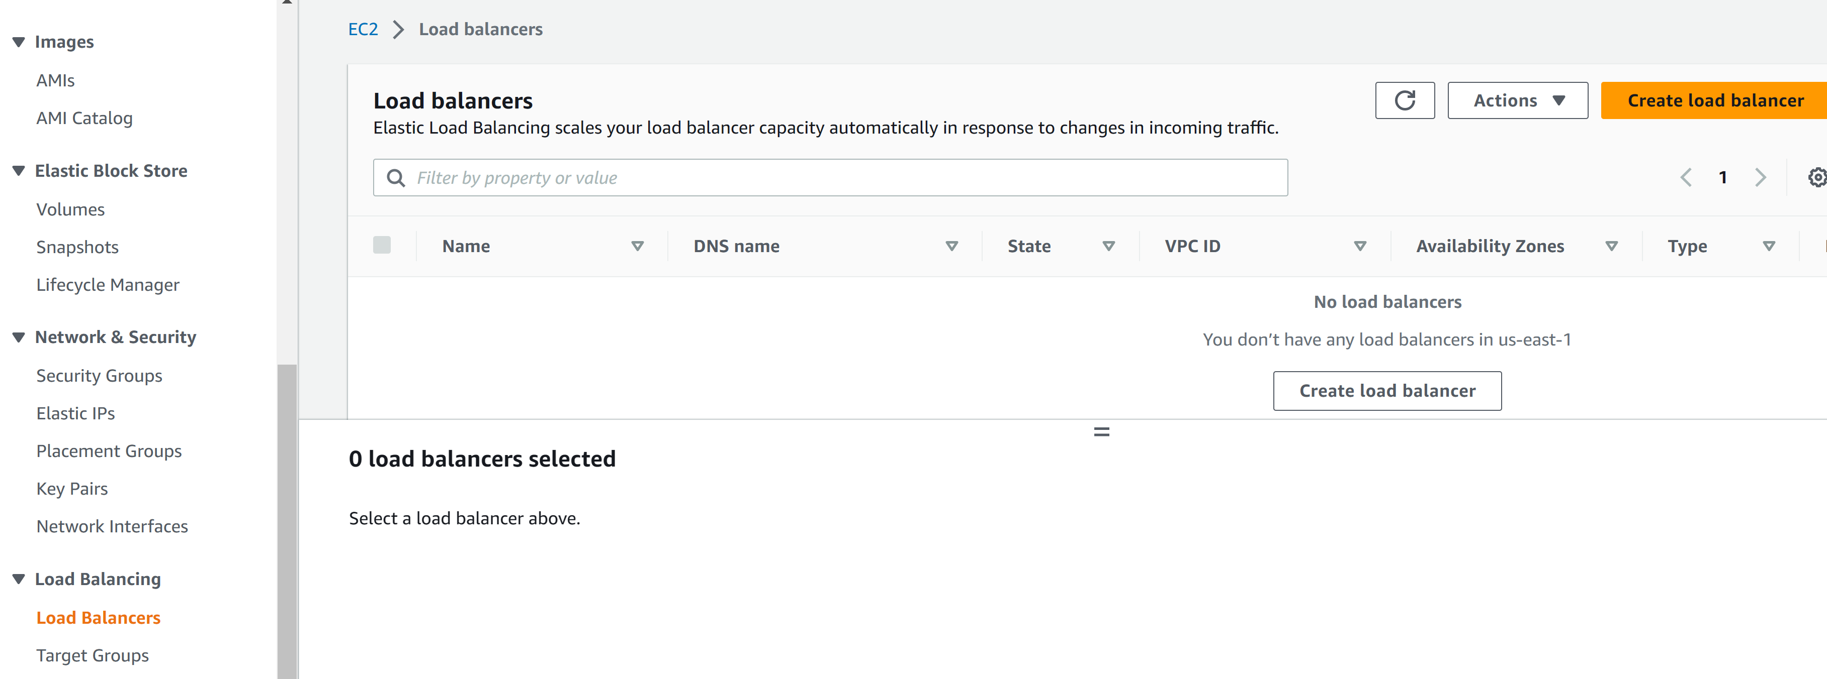

Step 10: got to application load balancer and click create

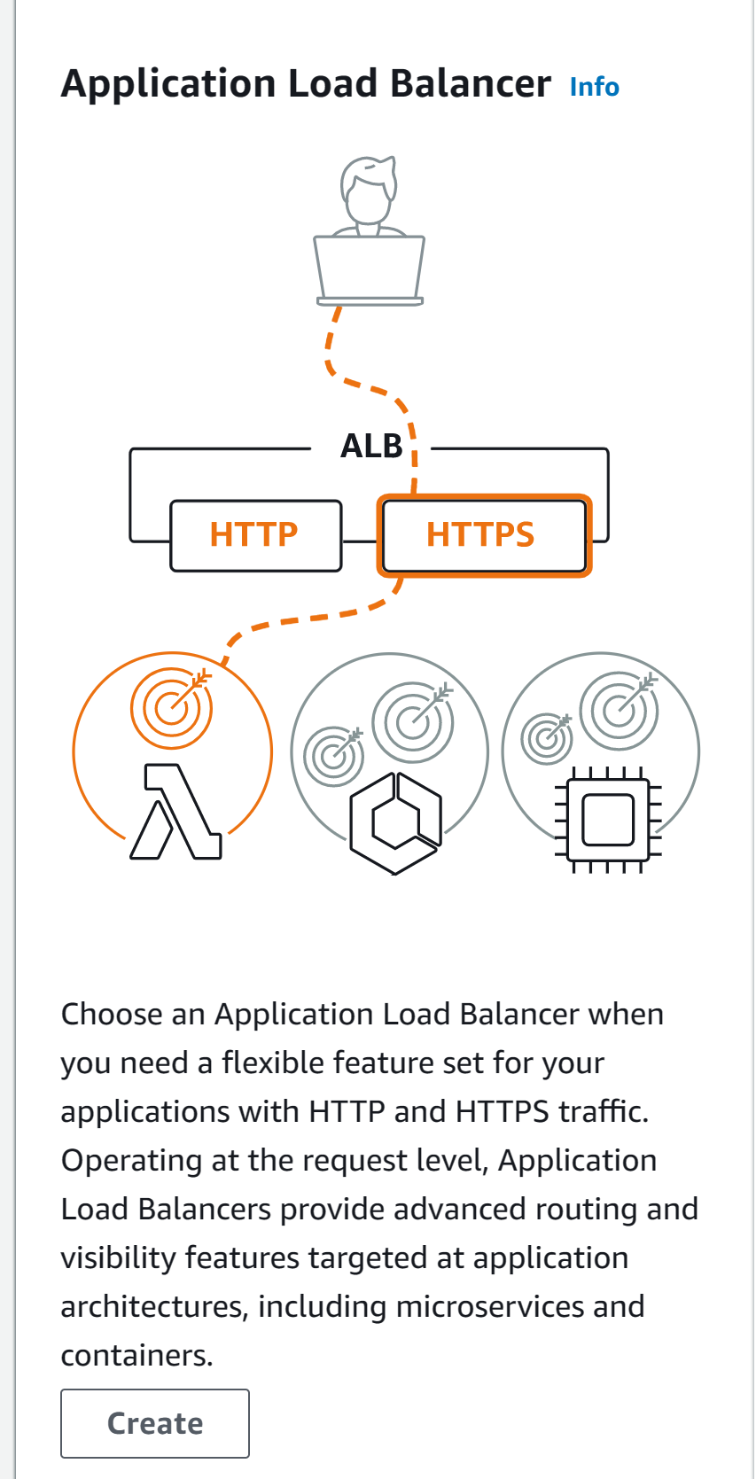

Step 11: configure the following

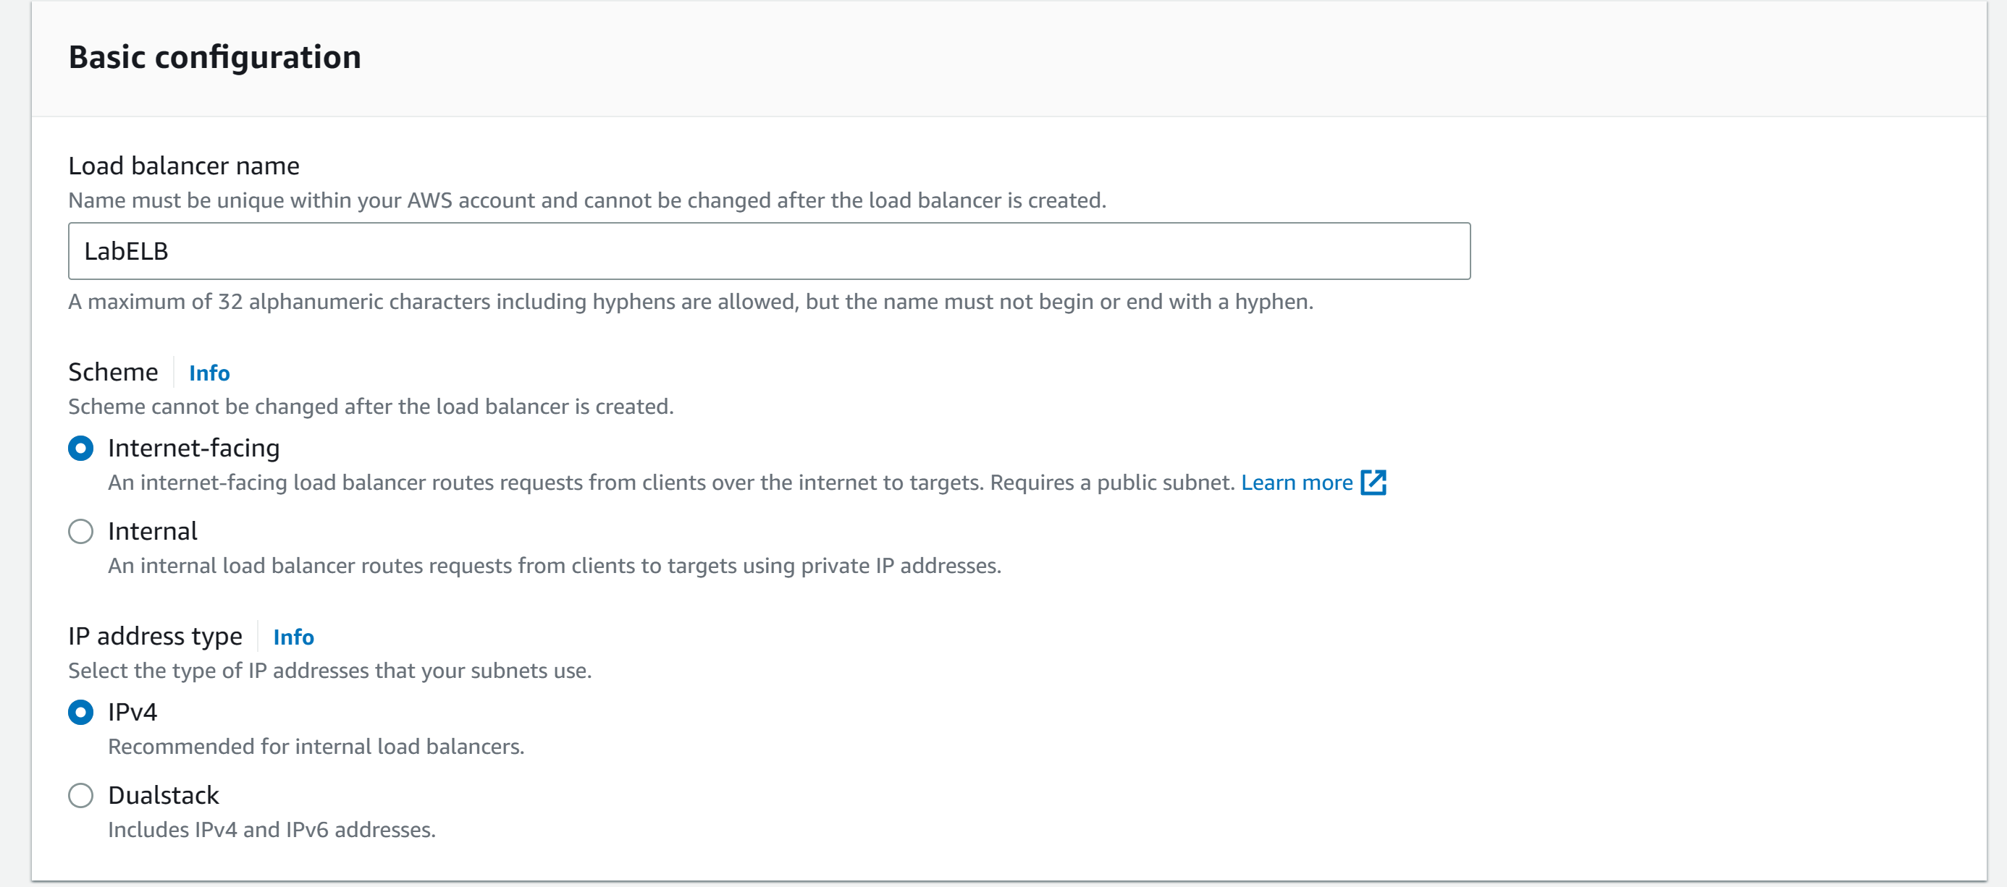

Step 12: configure the following

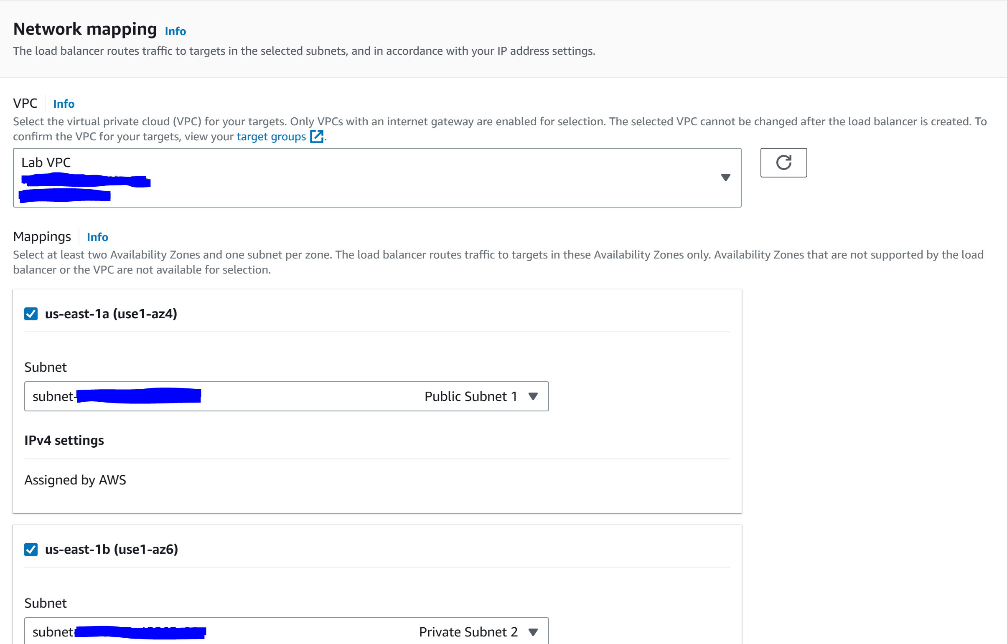

Step 13: configure the following

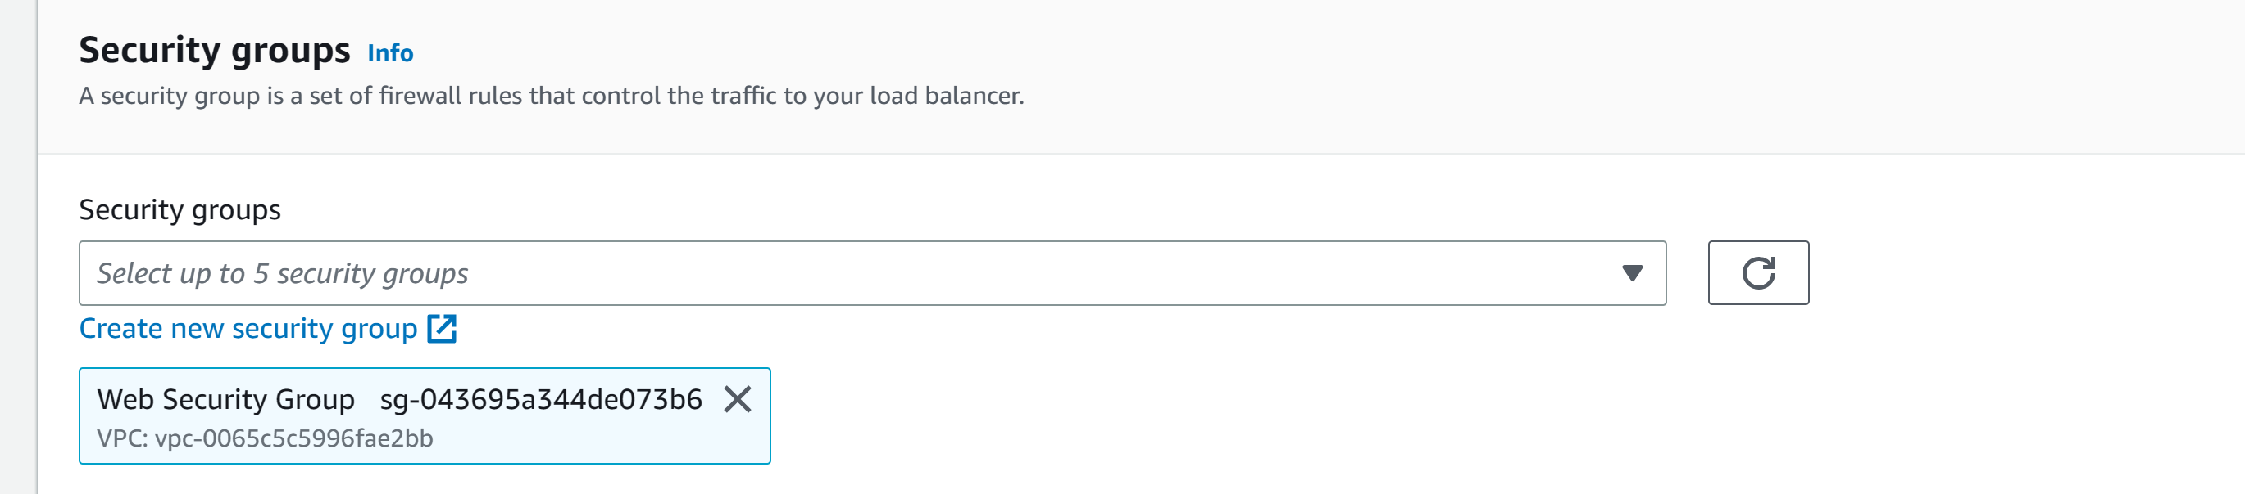

Step 14: configure the following and click create load balancer. Click view load balancer

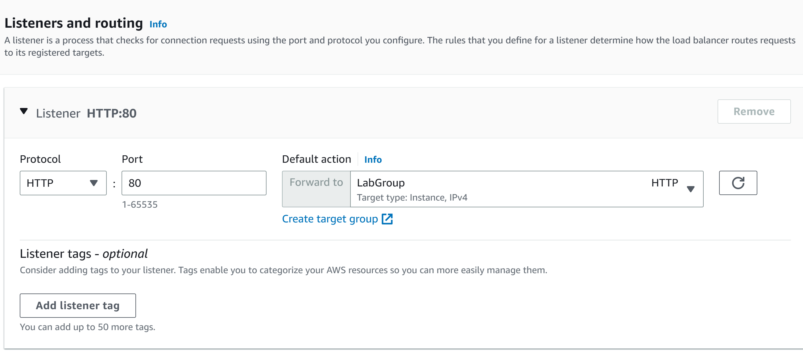

Step 15: go to Launch Configurations and click create launch configuration

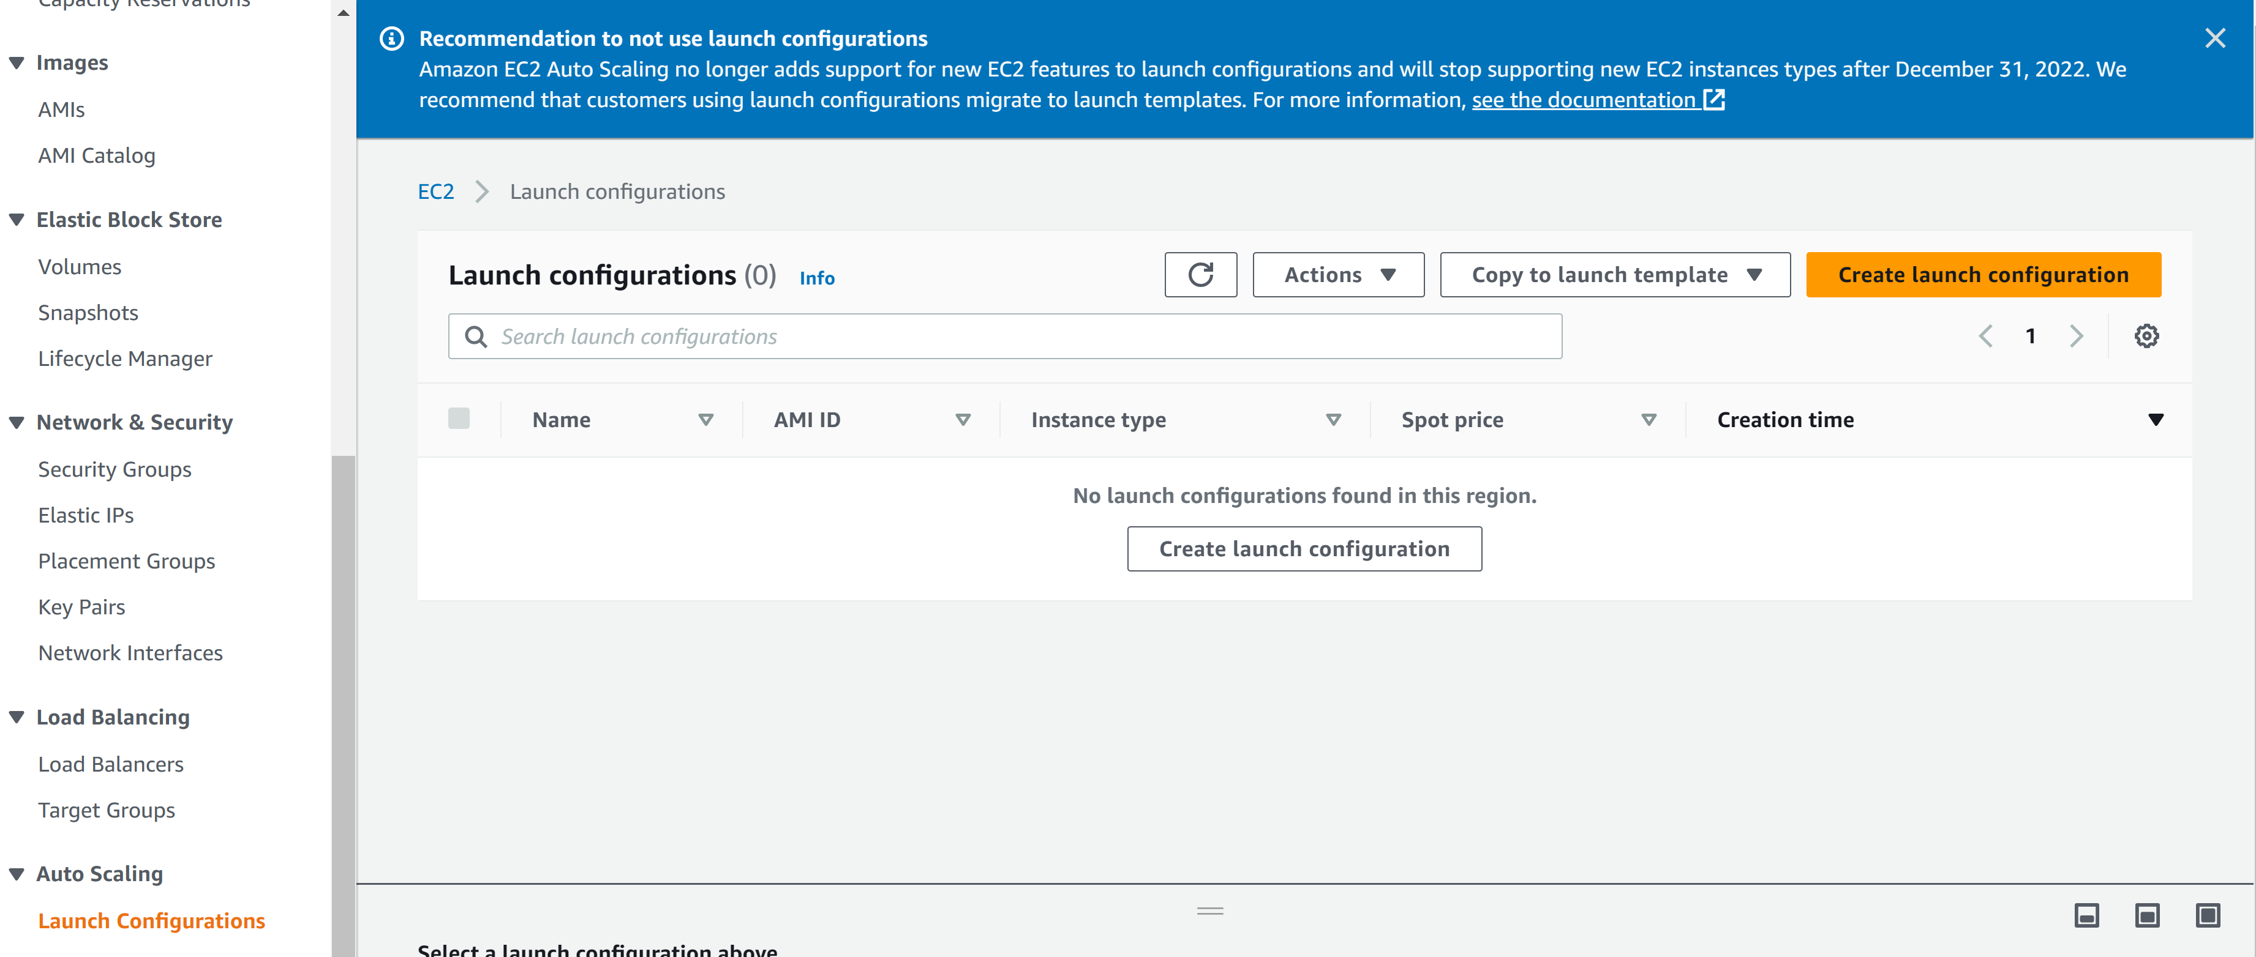

Step 16: configure the following

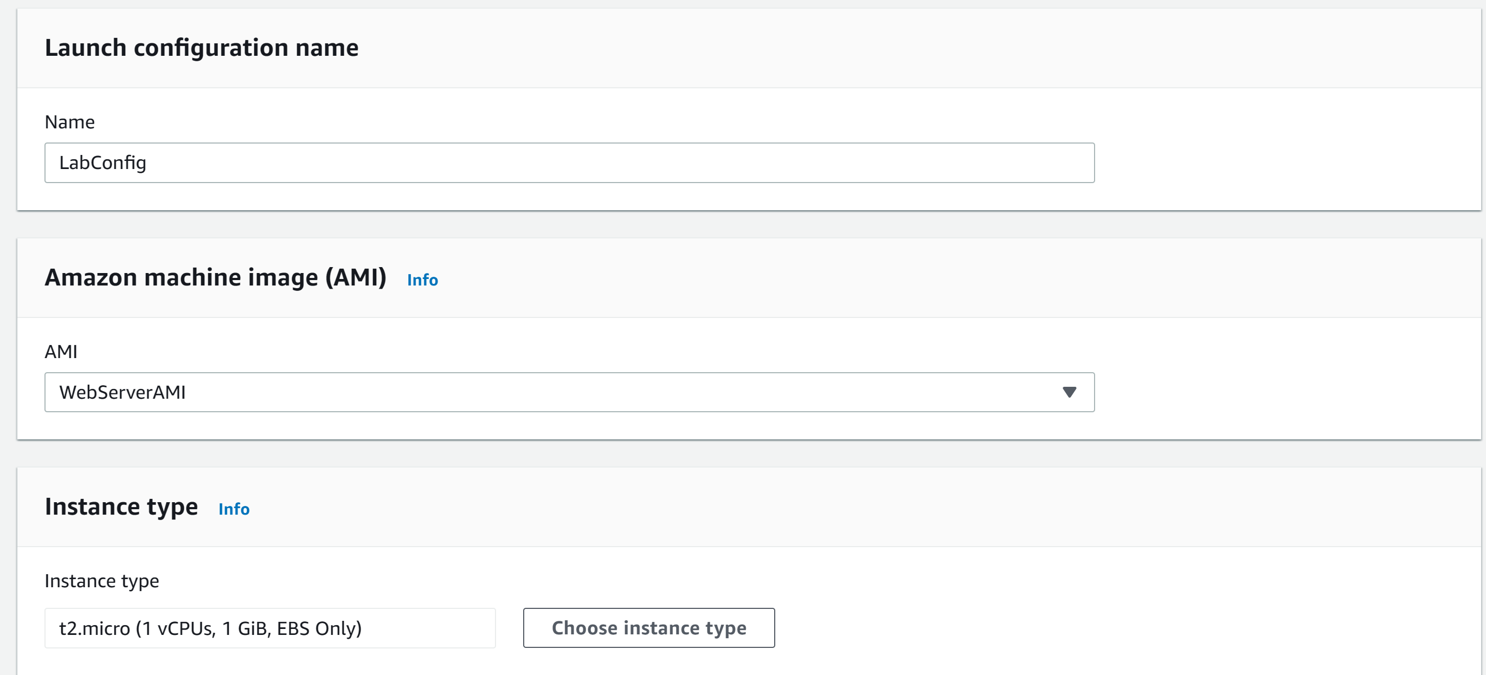

Step 17: configure the following

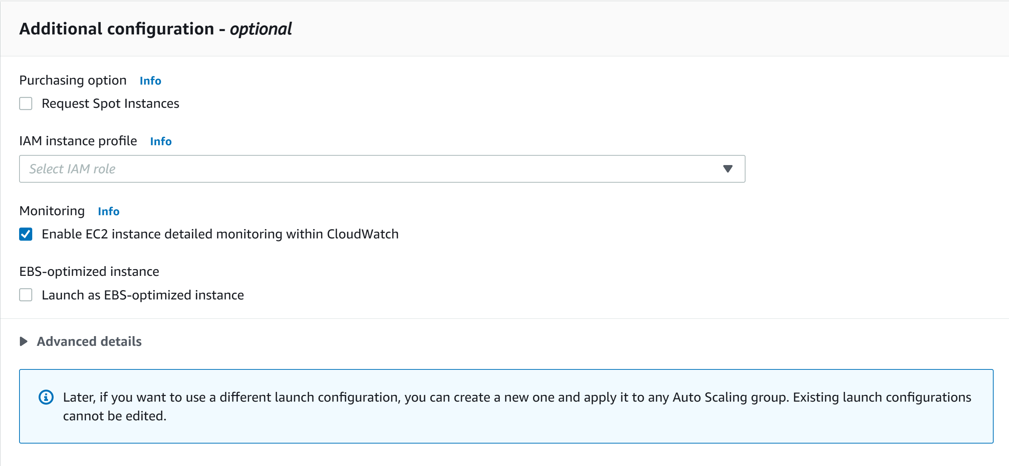

Step 18: configure the following

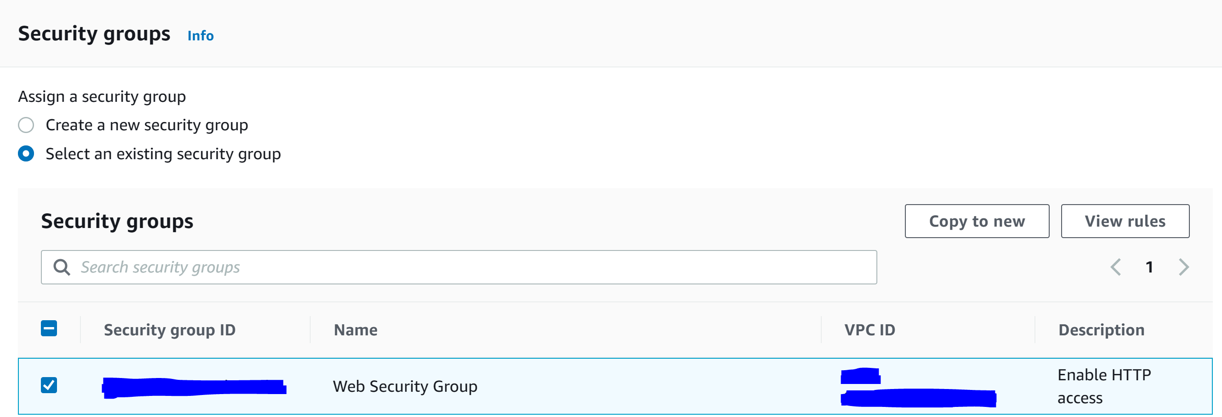

Step 19: configure the following and click Create launch configuration

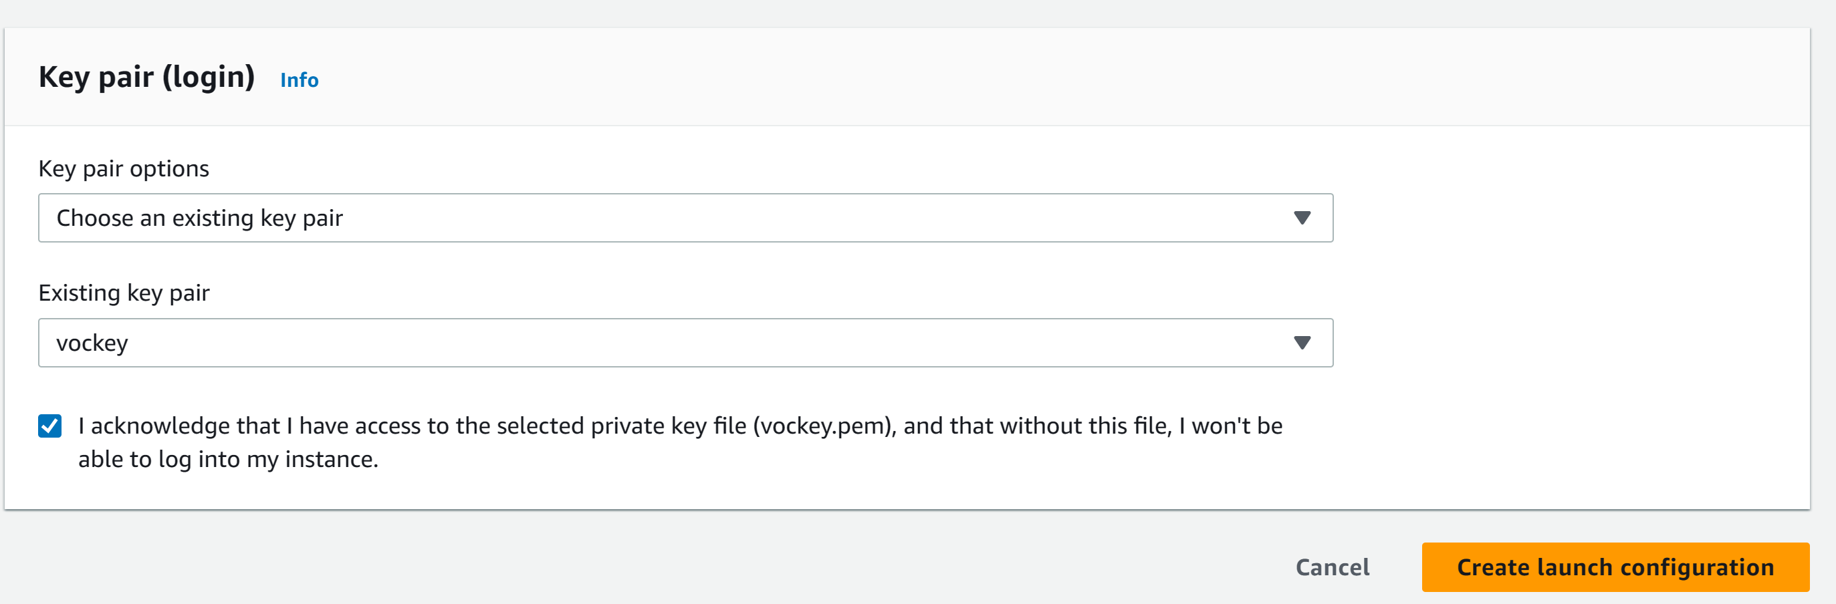

Step 20: go to actions and click Create Auto Scaling group

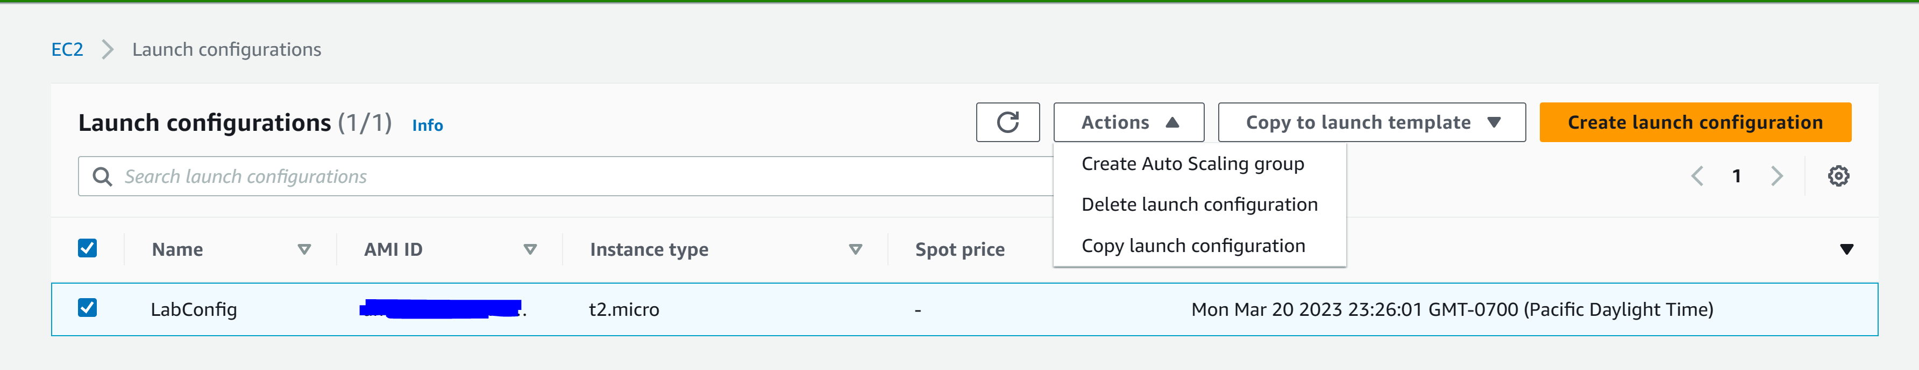

Step 21: configure the following and click Next

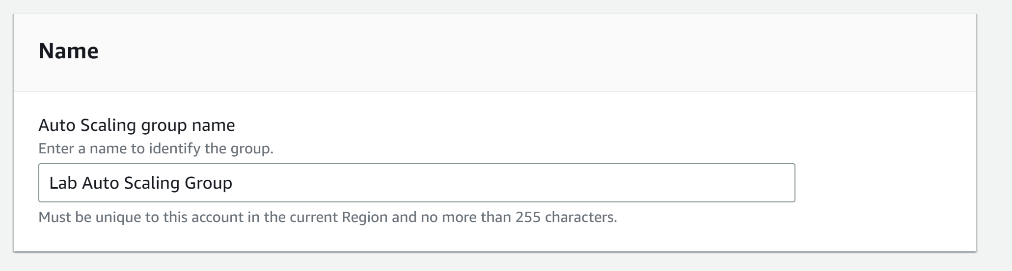

Step 22: configure the following and click next

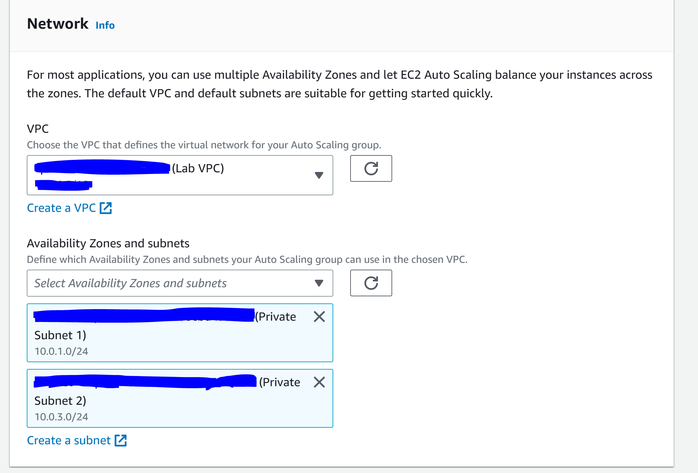

Step 23: configure the following

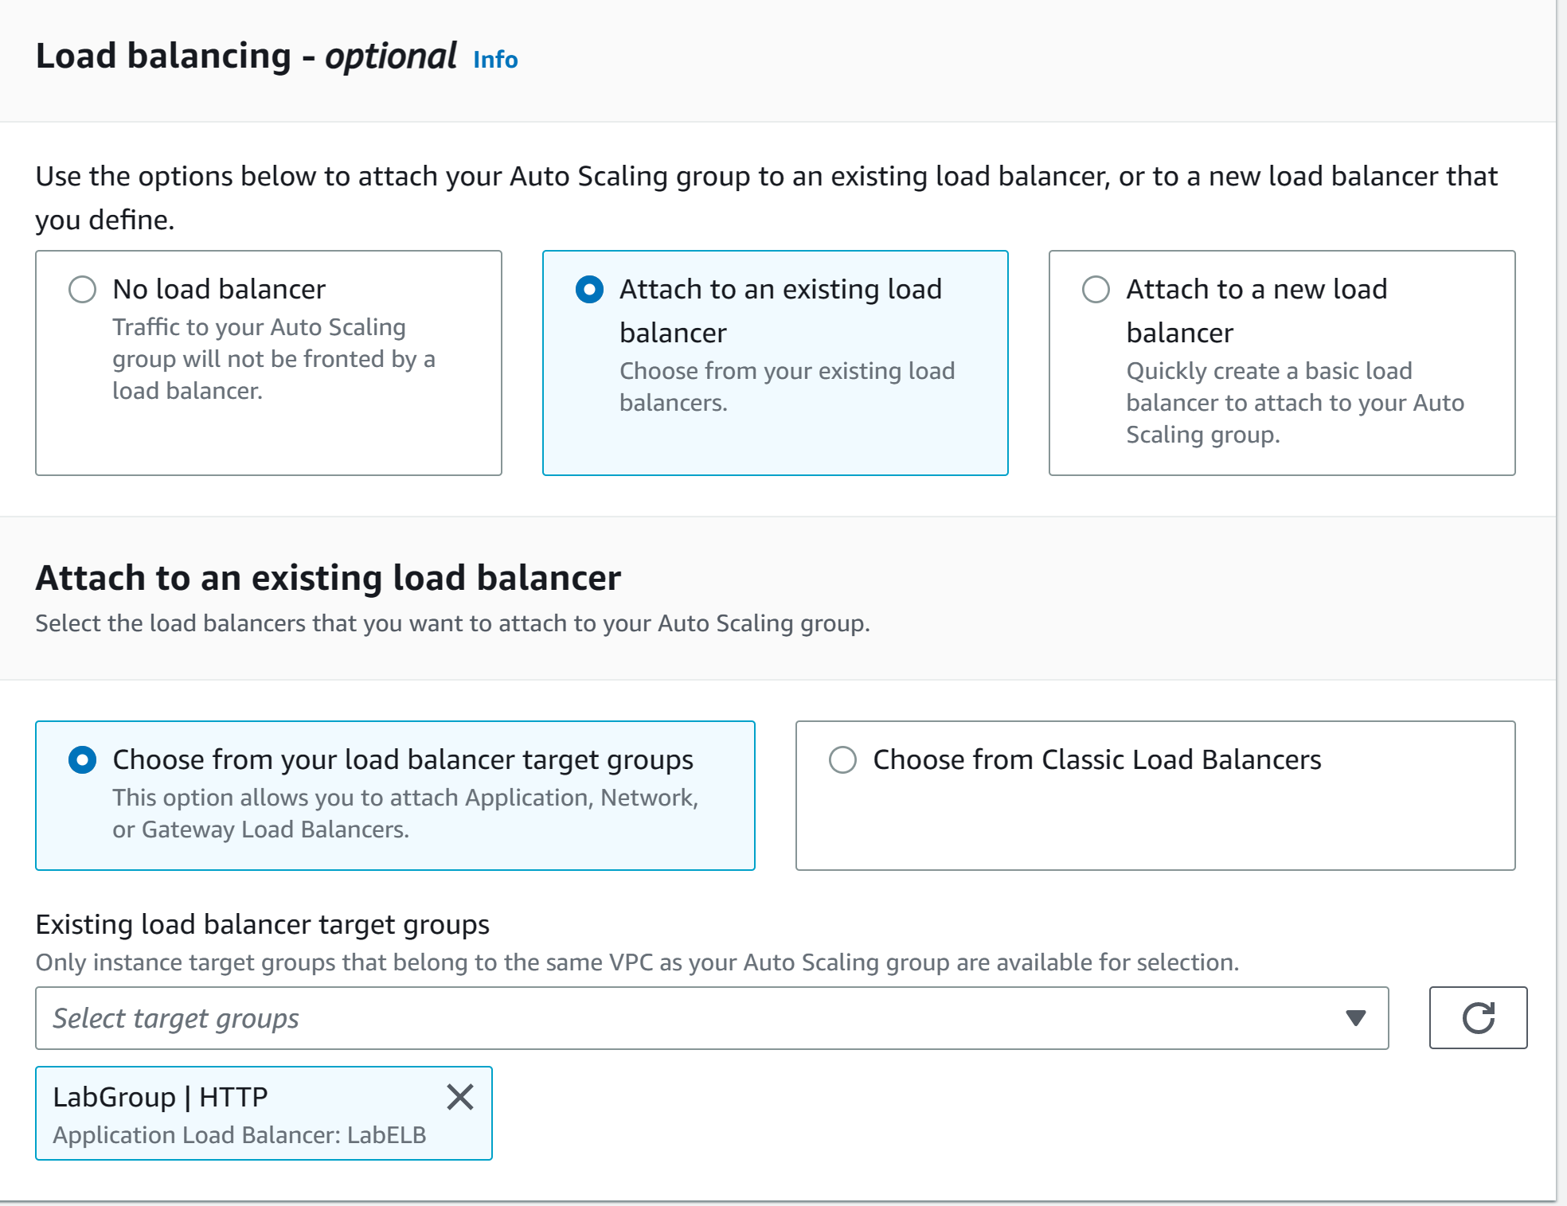

Step 24: configure the following and click next

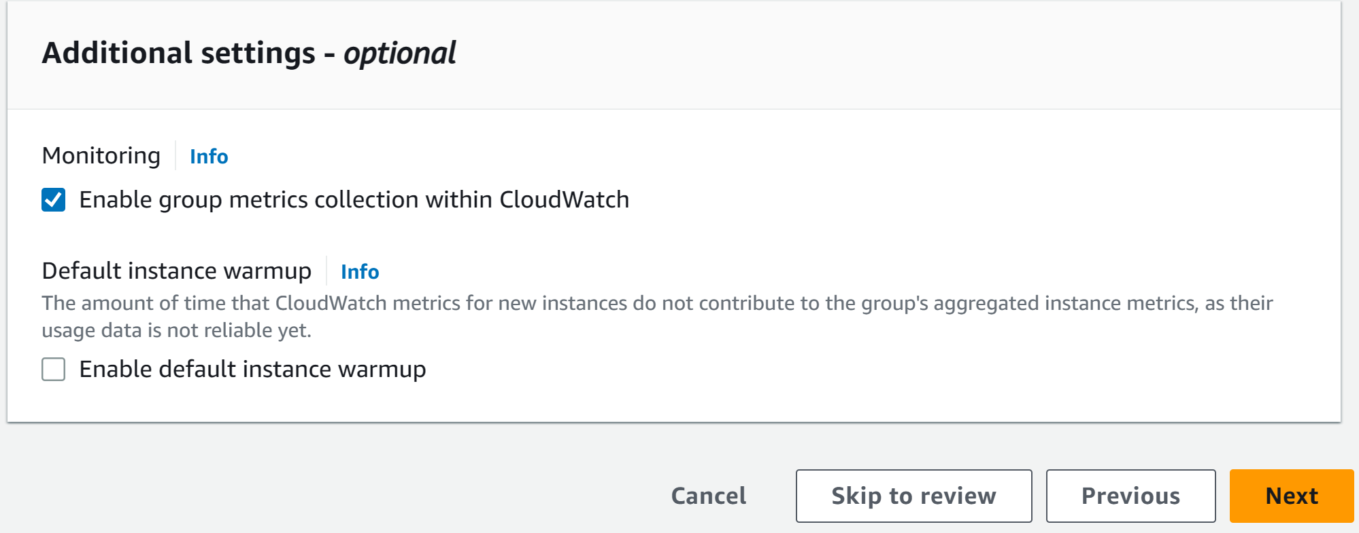

Step 25: configure the following

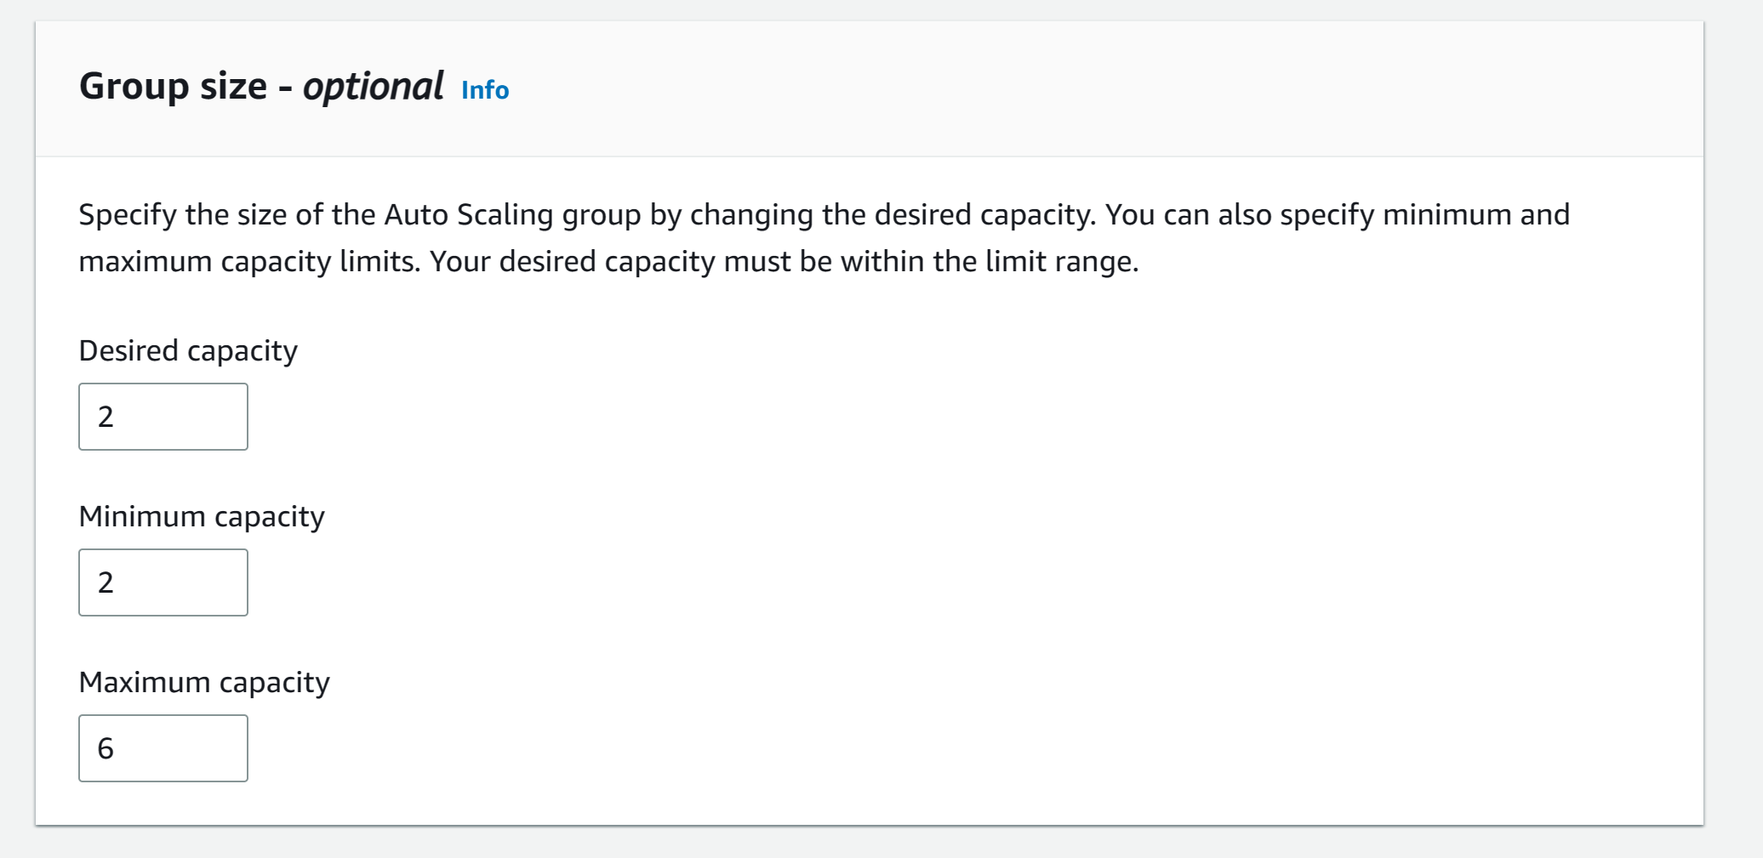

Step 26: configure the following and click next

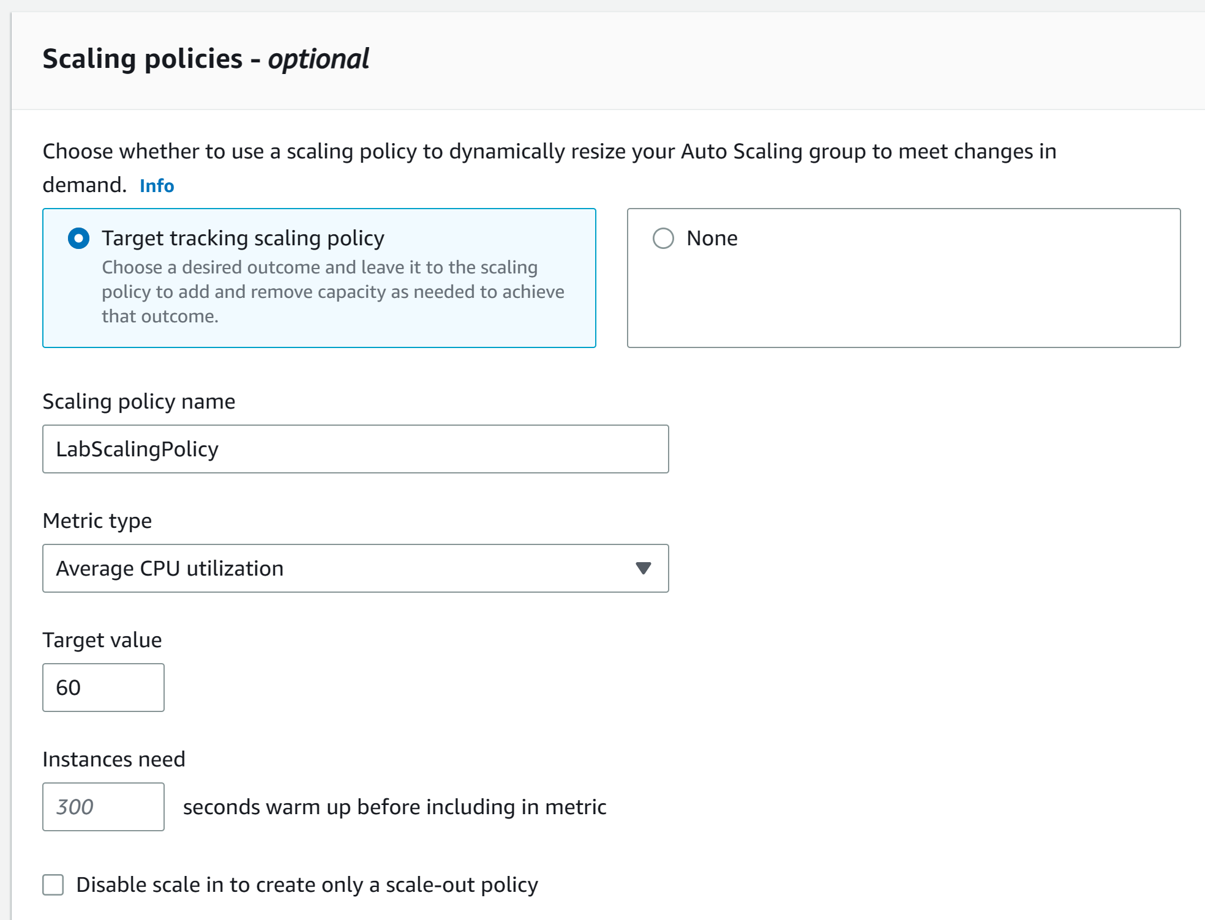

Step 27: click next again

Step 28: configure the following and click next. Click Create Auto Scaling Group

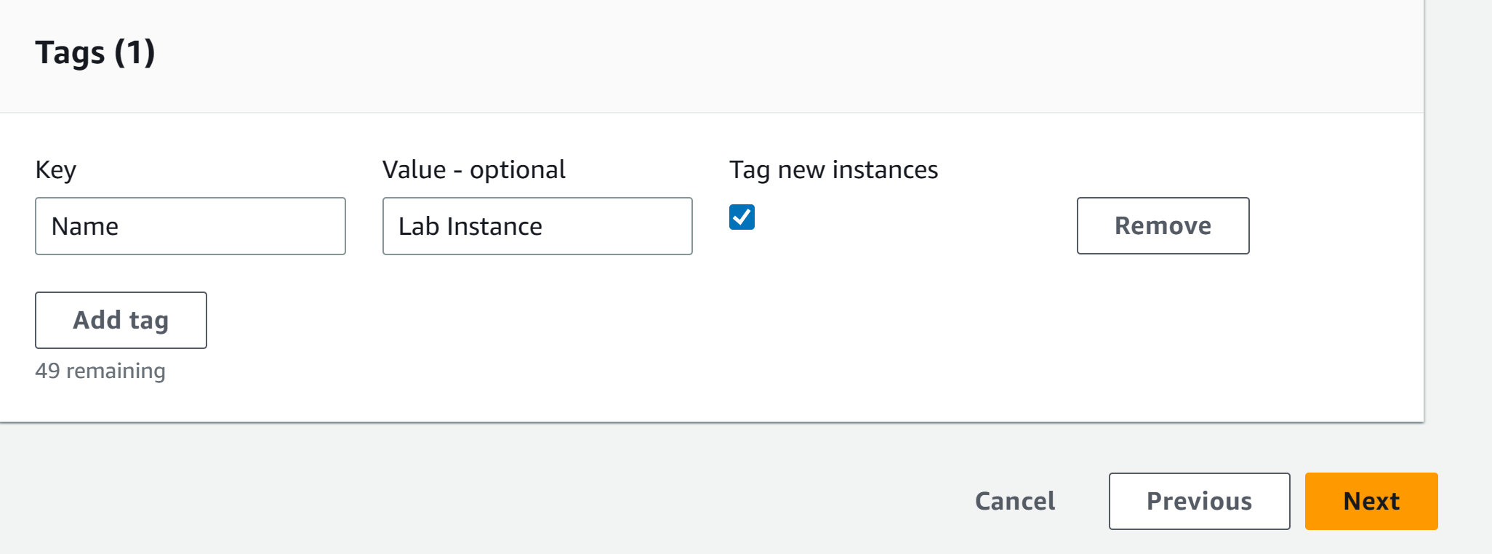

Step 29: go to Load Balancers and copy the DNS name

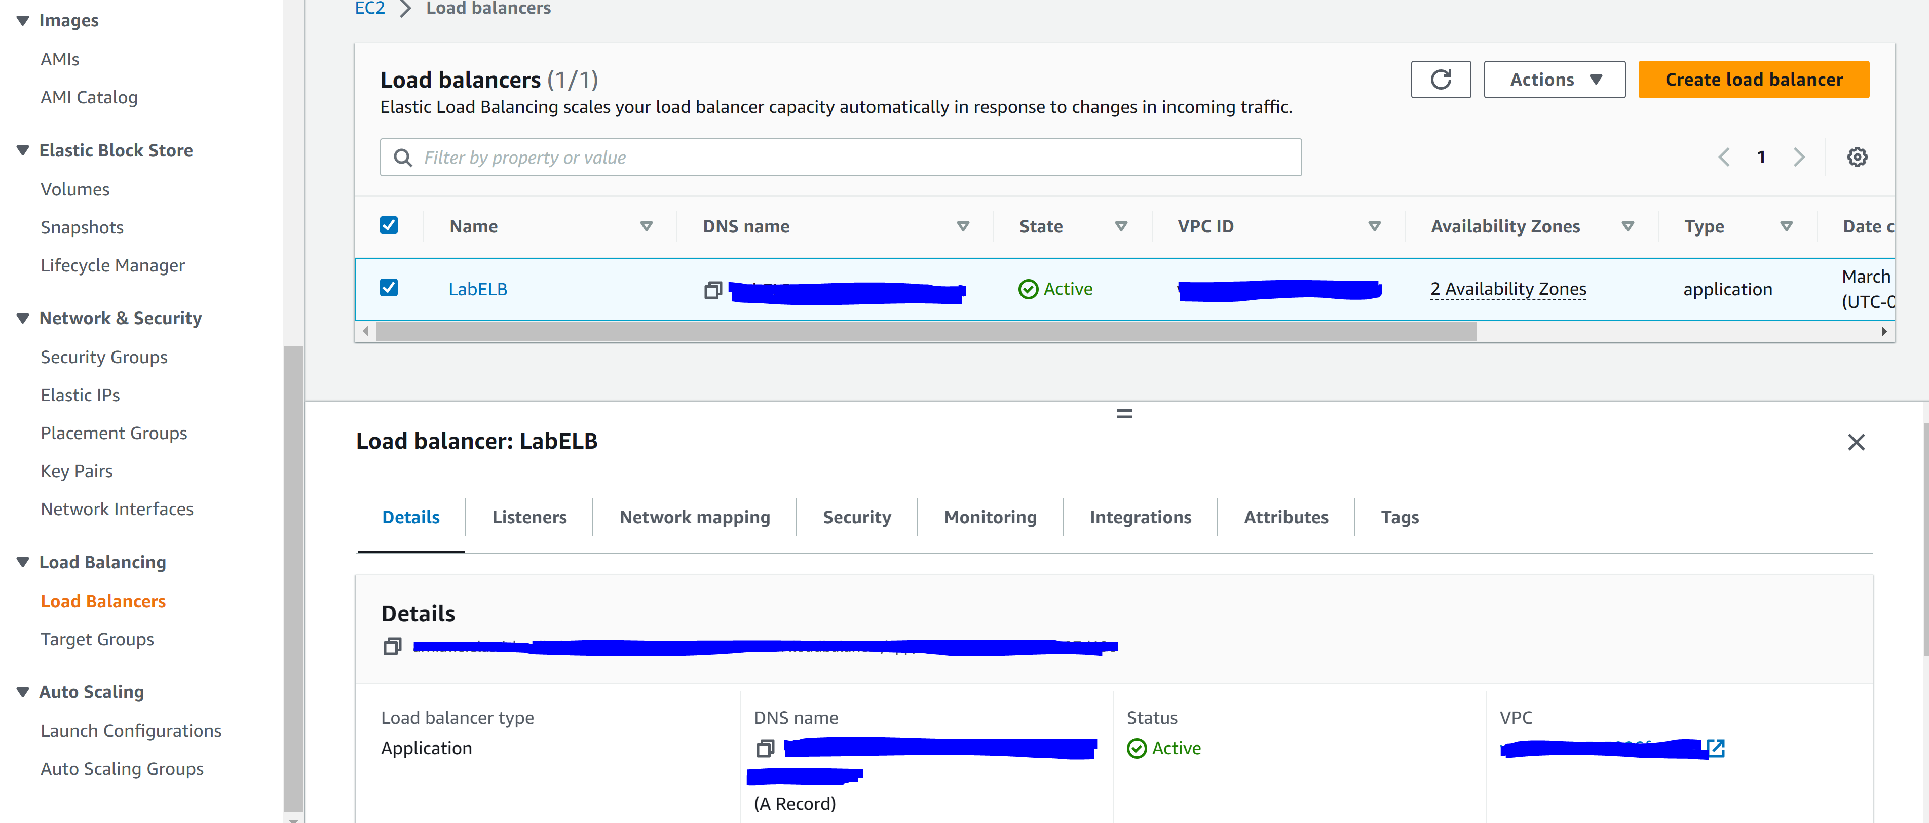

Step 30: paste the DNS into a browser search bar

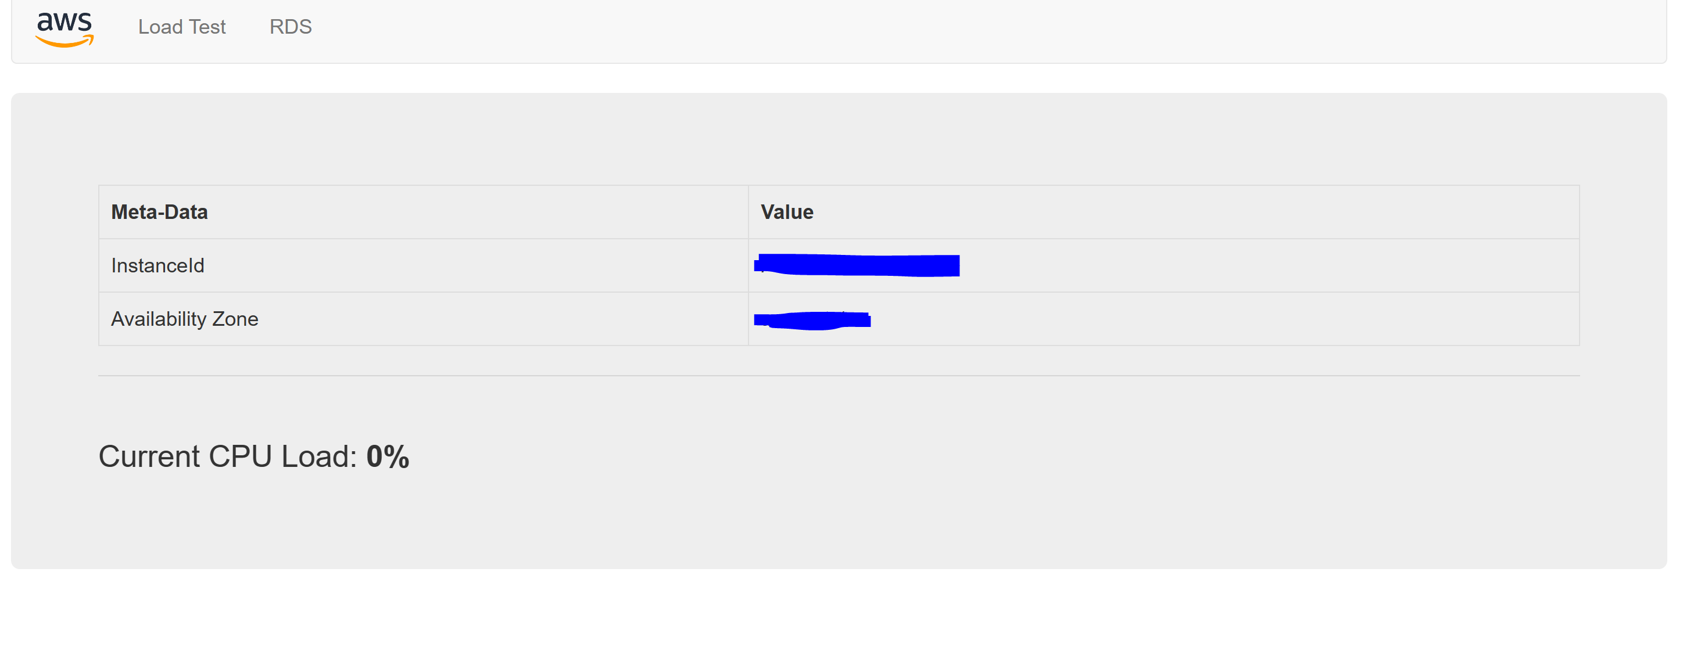

Step 31: go to services and click CloudWatch

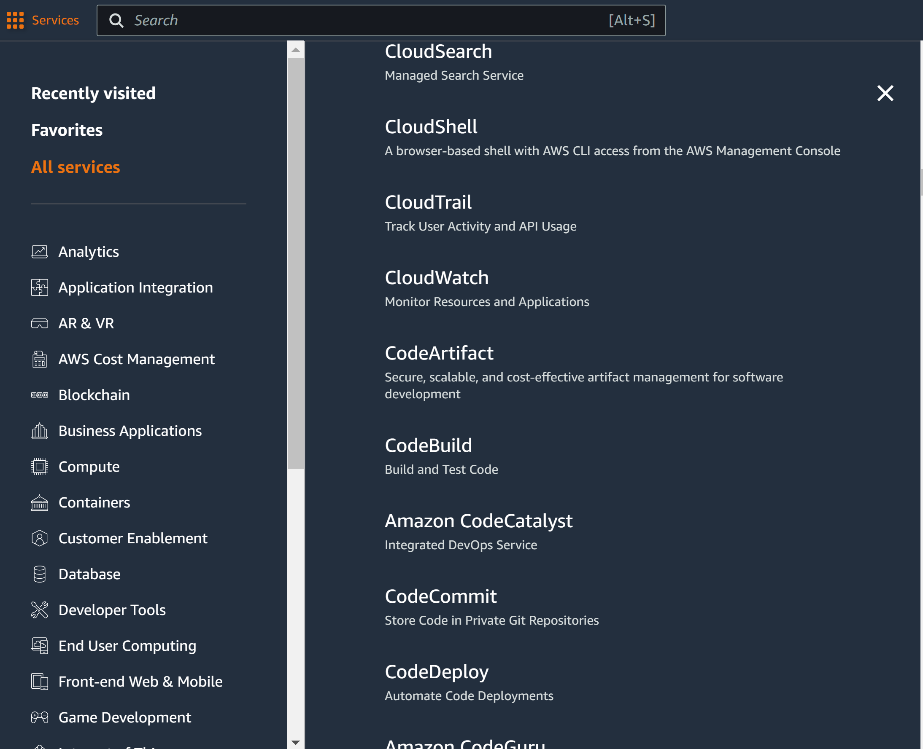

Step 32: click all Alarms and verify there are two alarms

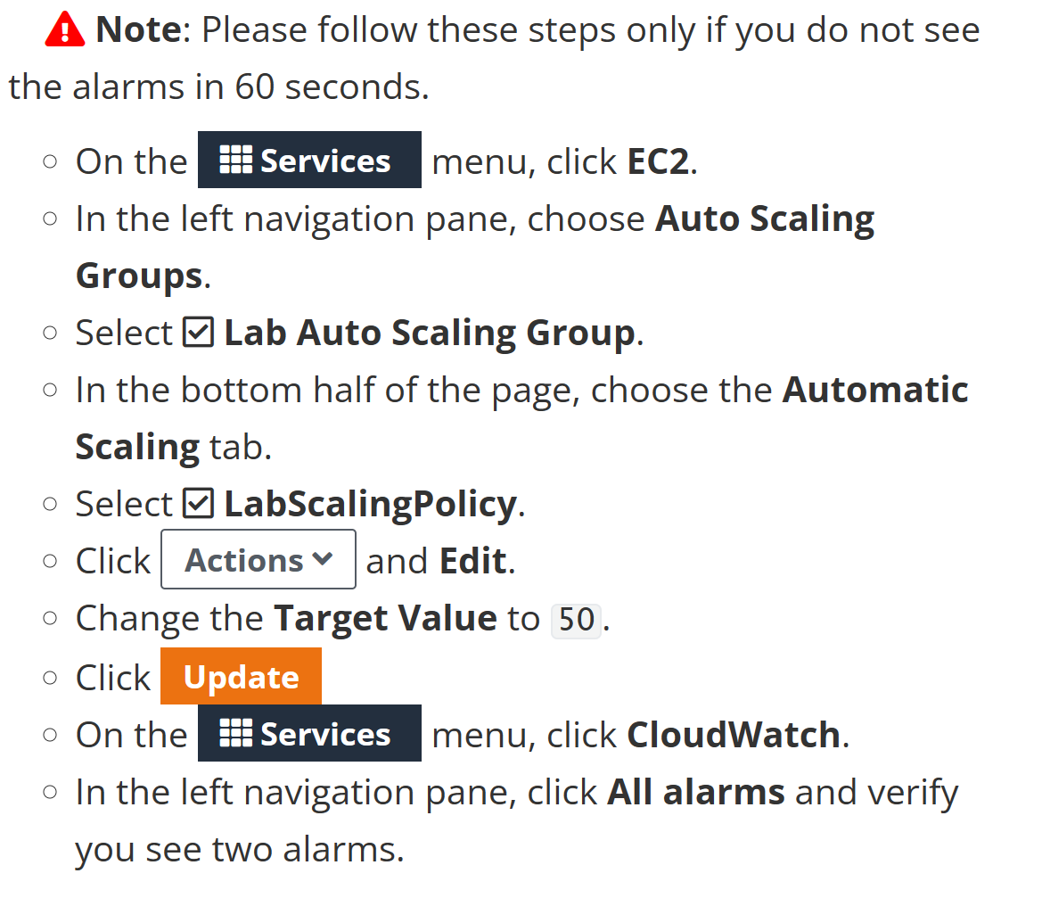

Step 33: go here

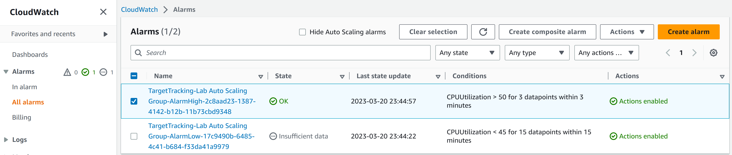

Step 34: go back to the web browser and click load test

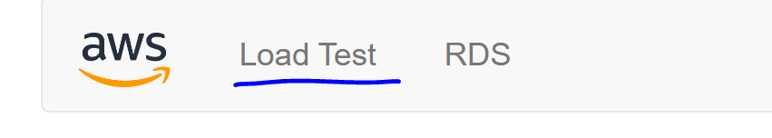

Step 35: wait for the alarm to say in alarm

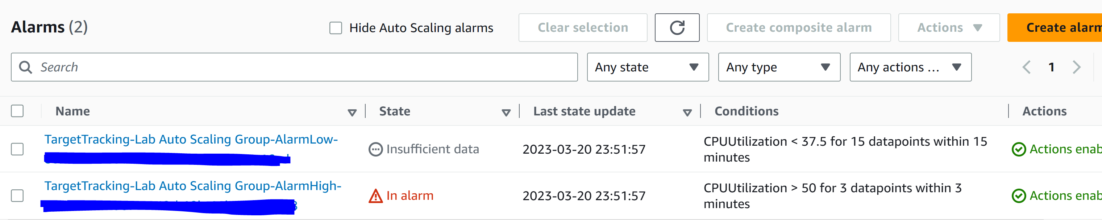

Step 36: go to Services and EC2

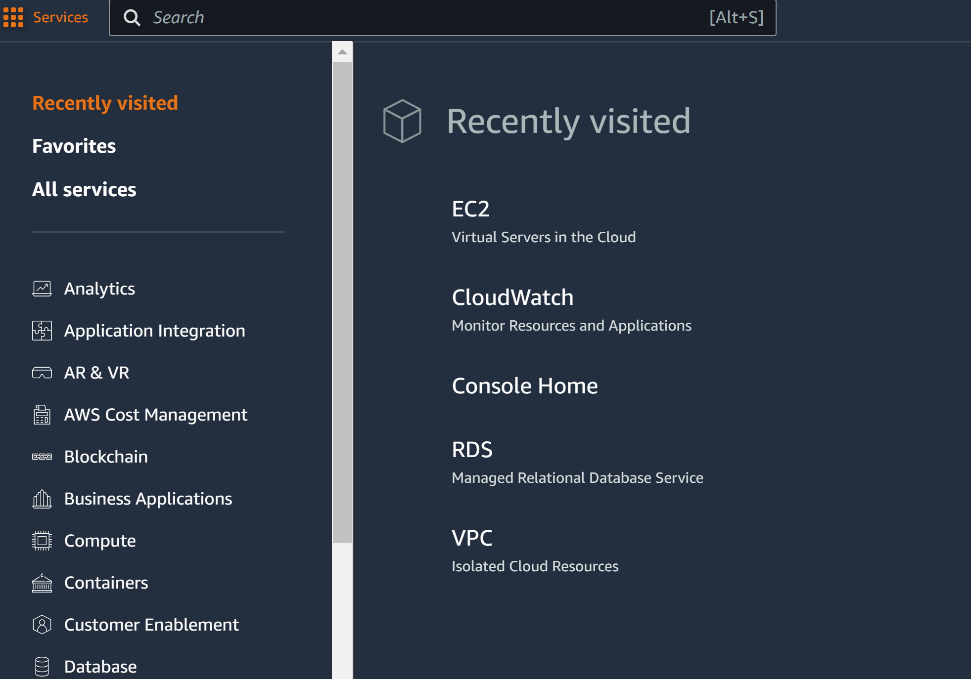

Step 37: more EC2 instances should have been launched in response to the alarm

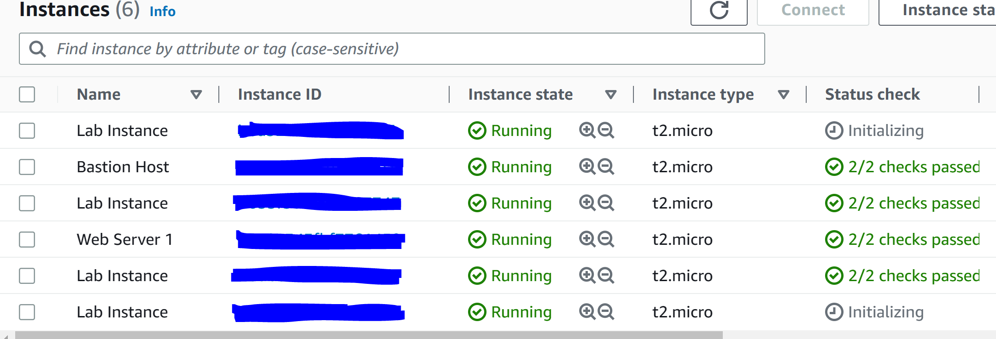

Step 38: click Web Server 1, instance state, and click Terminate instance

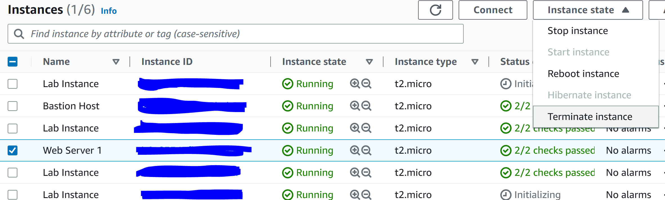

Step 39: click End Lab

Conclusion

This lab covers the AWS Cloud Foundations Certification curriculum modules 7-10. The modules include three hands on labs and have also been completed in this lab report. There were no problems with the lab since everything was very telegraphed with no uncertainty.